# Project Overview

The Medical Inventory Management System is designed to streamline the process of managing medicines, equipment, and other medical supplies in hospitals, clinics, and pharmacies. The system helps in tracking stock levels, monitoring expiry dates, generating purchase orders, and reducing wastage due to overstocking or understocking. It ensures efficient inventory control, cost savings, and timely availability of critical medical items.

# Problem Statement

Healthcare facilities often struggle with manual inventory management systems, leading to challenges such as:

* Overstocking or shortage of medicines.
* Difficulty in tracking expiry dates and batch numbers.
* Lack of real-time updates on available stock.
* Human errors in manual record-keeping.
* Inefficient procurement and supply chain management.

These issues can directly impact patient care, increase operational costs, and result in financial losses.

# Objectives

1. To develop a system that automates inventory tracking of medicines and medical equipment.
2. To provide real-time stock status, including alerts for low stock and near-expiry items.
3. To generate reports on inventory usage, purchase history, and supplier performance.
4. To reduce human errors and improve accuracy in inventory records.
5. To ensure cost-effectiveness and better decision-making in procurement.

# Student Outcomes

By completing this project, students will be able to:

* Apply database design and management skills in real-world applications.
* Develop problem-solving and analytical thinking skills.
* Gain experience in system design, implementation, and testing.
* Understand the role of automation in healthcare management.
* Work collaboratively and communicate effectively through project documentation.

# Scope of the Project

* In-Scope Features:  
  + User authentication (Admin, Pharmacist, Staff).
  + Add, update, and delete medical items.
  + Stock monitoring with real-time updates.
  + Expiry date alerts and notifications.
  + Purchase order generation and supplier details management.
  + Reporting and analytics (daily, monthly, yearly).
* Out-of-Scope Features (Future Enhancements):  
  + Integration with hospital billing systems.
  + Mobile app for staff accessibility.
  + Barcode/RFID-based inventory tracking.
  + AI-driven demand forecasting.

# System Requirements

### *Hardware Requirements*

* Processor: Intel i3 or above
* RAM: 4 GB minimum
* Hard Disk: 500 GB
* Monitor: 15” LED/LCD
* Input Devices: Keyboard, Mouse
* Network: Stable internet connection (for cloud-based system)

### *Software Requirements*

* Operating System: Windows 10 / Linux / MacOS
* Database: MySQL / PostgreSQL / Oracle
* Backend: Java / Python / PHP / Node.js
* Frontend: HTML, CSS, JavaScript, React/Angular (optional)
* Server: Apache Tomcat / XAMPP / Node.js
* IDE/Tools: VS Code, Eclipse, or IntelliJ IDEA

### **Milestone 1-Salesforce Account**

Introduction:

Are you new to Salesforce? Not sure exactly what it is, or how to use it? Don’t know where you should start on your learning journey? If you’ve answered yes to any of these questions, then you’re in the right place. This module is for you.

Welcome to Salesforce! Salesforce is game-changing technology, with a host of productivity-boosting features, that will help you sell smarter and faster. As you work toward your badge for this module, we’ll take you through these features and answer the question, “What is Salesforce, anyway?”.

What Is Salesforce?

Salesforce is your customer success platform, designed to help you sell, service, market, analyze, and connect with your customers.

Salesforce has everything you need to run your business from anywhere. Using standard products and features, you can manage relationships with prospects and customers, collaborate and engage with employees and partners, and store your data securely in the cloud. So what does that really mean? Well, before Salesforce, your contacts, emails, follow-up tasks, and prospective deals might have been organized something like this:

<https://youtu.be/r9EX3lGde5k>

### **Activity 1: Creating Developer Account**

Creating a developer org in salesforce.

1. Go to <https://developer.salesforce.com/signup>
2. On the sign up form, enter the following details :

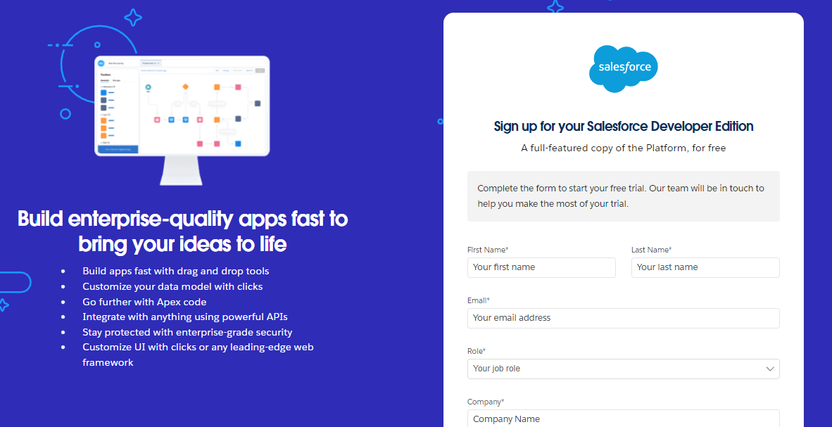

1. First name & Last name
2. Email
3. Role : Developer
4. Company : College Name
5. County : India
6. Postal Code : pin code
7. Username : should be a combination of your name and company

This need not be an actual email id, you can give anything in the format : username@organization.com

Click on sign me up after filling these.

### **Activity 2: Account Activation**

1. Go to the inbox of the email that you used while signing up. Click on the verify account to activate your account. The email may take 5-10mins.

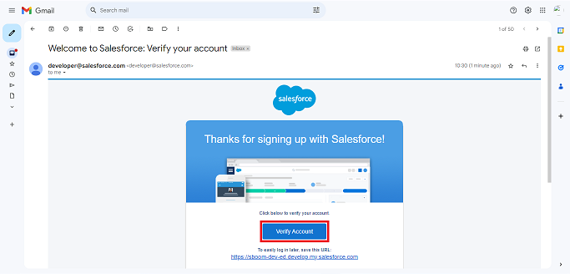

1. Click on Verify Account
2. Give a password and answer a security question and click on change password.

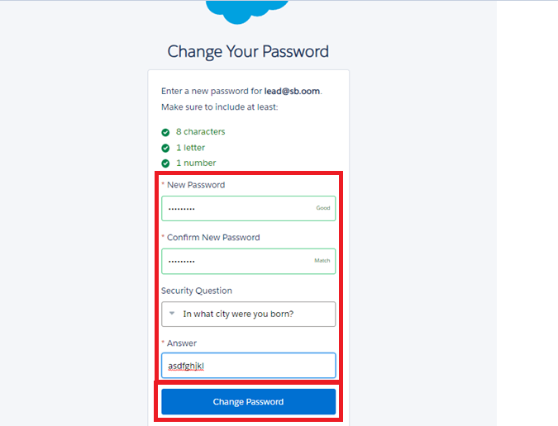

1. Then you will redirect to your salesforce setup page.

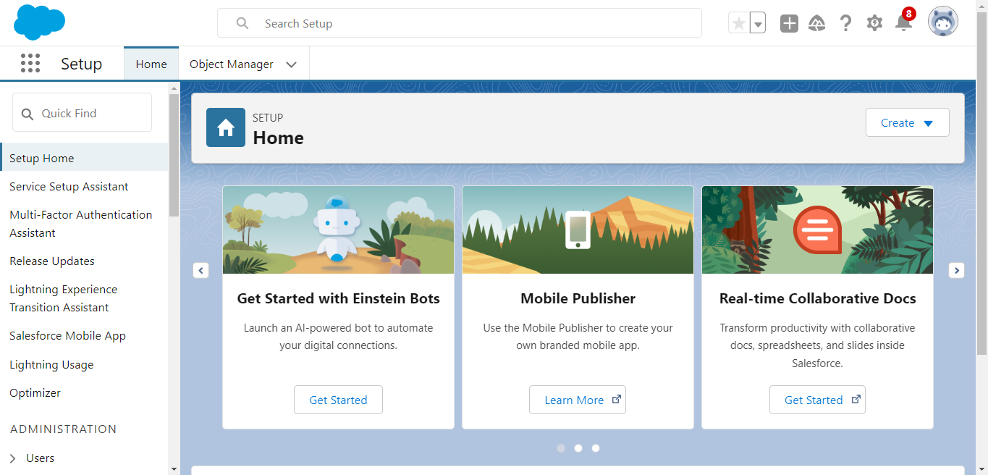

### **Milestone 2- Objects**

In Salesforce, objects are database tables that allow you to store data specific to your organization.

### **Activity 1: Creating a Product Object**

To create an object:

1. From the setup page
2. Click on Object Manager
3. Click on Create >> Click on Custom Object.
4. Enter the label name as Product
5. Enter Plural label name as Products
6. Enter Record Name as Product ID
7. Select Data Type as Text.
8. Select Allow reports.
9. Select Allow search.
10. Click on Save and New

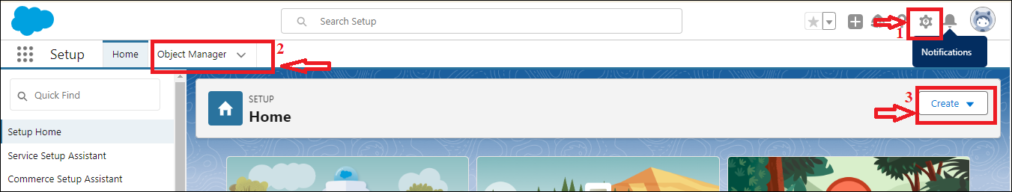

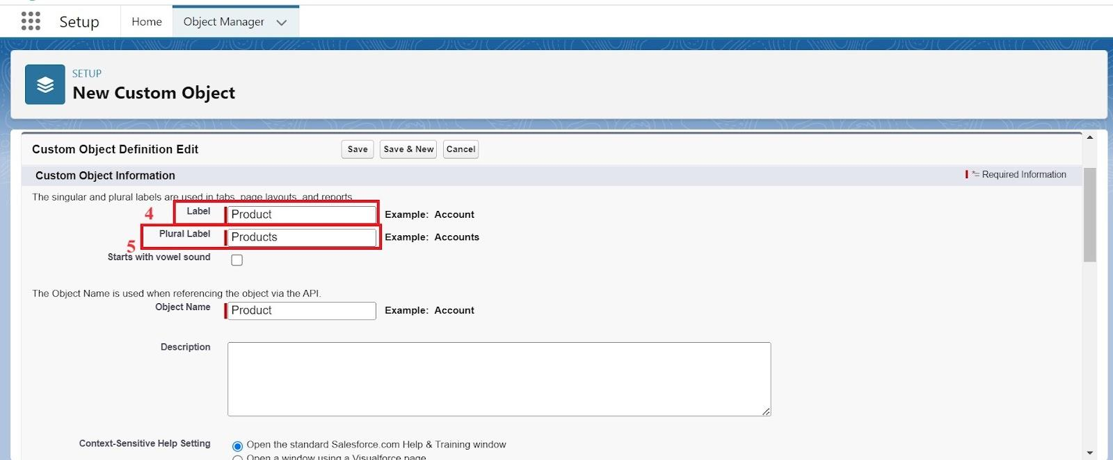

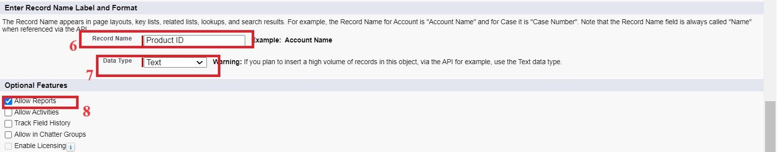

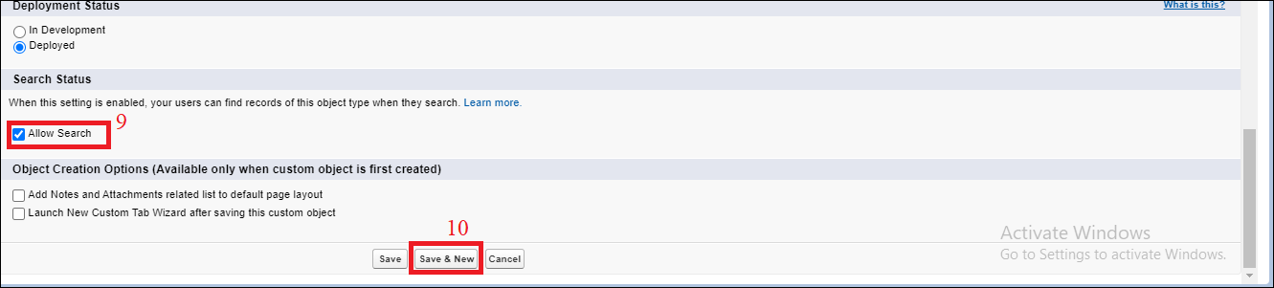

In the same way Create Purchase Order, Order Item, Inventory Transaction and Supplier objects.

### **Activity 2: Account Activation**

1. Go to the inbox of the email that you used while signing up. Click on the verify account to activate your account. The email may take 5-10mins.



1. Click on Verify Account
2. Give a password and answer a security question and click on change password.



1. Then you will redirect to your salesforce setup page.



### 

### 

### **Milestone 3- Tabs**

In Salesforce, tabs are used to make the data stored in objects accessible to users through the user interface. Tabs are a fundamental part of the Salesforce interface, providing a way to navigate to different objects and records.

### **Activity 1: Creating a tab for Product Object**

1. Go to the setup page >> type Tabs in Quick Find bar
2. Click on tabs
3. Click on New (under custom object tab).
4. Select Object(Product) >> Select the tab style
5. Click on Next >> (Add to profiles page) keep it as default >> Click on Next (Add to Custom App) uncheck the include tab .
6. Make sure that the Append tab to user’s existing personal customizations is checked.
7. Click save

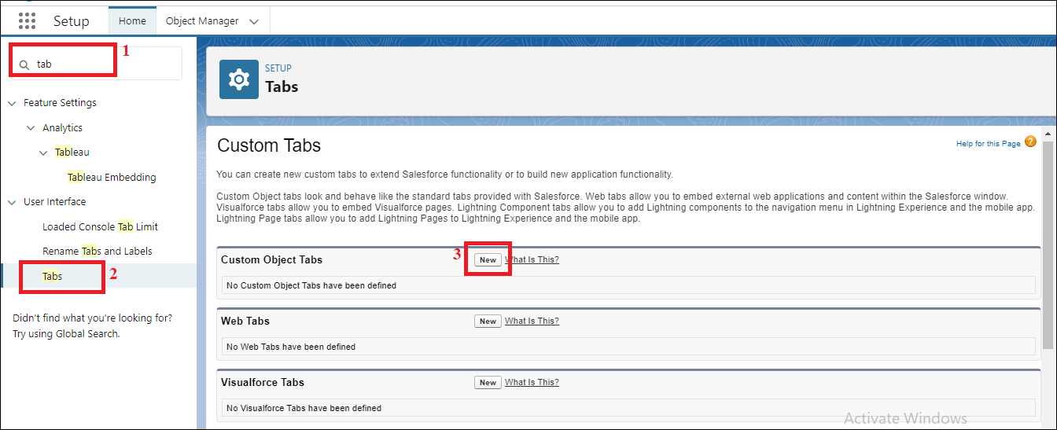

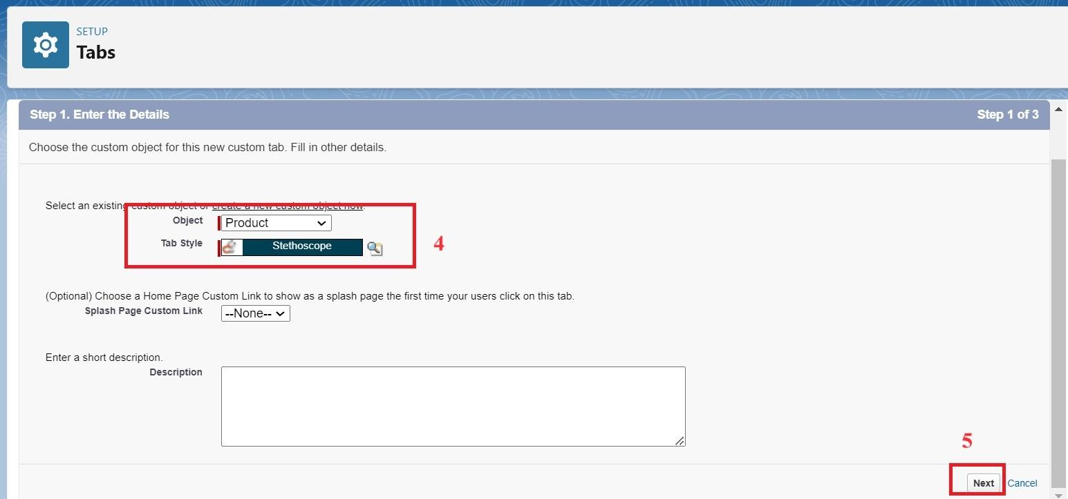

**Activity 2: Creating Remaining Tabs**

1. Now create the Tabs for the remaining Objects, they are “Purchase Order, Order Item, Inventory Transaction, Supplier”.
2. Follow the same steps as mentioned in Activity -1 .

### 

### **Milestone 4- The Lightning App**

A Lightning App in Salesforce is a collection of items that work together to serve a particular function for the end-users. These items can include standard and custom objects, tabs, utilities, and other productivity tools. Lightning Apps are designed to provide a more intuitive and efficient user experience compared to traditional Salesforce apps.

### **Activity 1: Create a Lightning App for Medical Inventory Management**

1. From Setup, enter App Manager in the Quick Find and select App Manager.
2. Click New Lightning App.
3. Enter Medical Inventory Management as the App Name >> Click on upload image and add an image related to Medical Inventory then click next
4. Under App Options, leave the default selections and click next.
5. Under Utility Items, leave as is and click Next.
6. From Available Items, select Products, Purchase Orders, Order Items, Inventory Transactions, Suppliers, Reports, and Dashboards and move them to Selected Item and Click Next.
7. From Available Profiles, select System Administrator and move it to Selected Profiles.
8. Click Save & Finish.

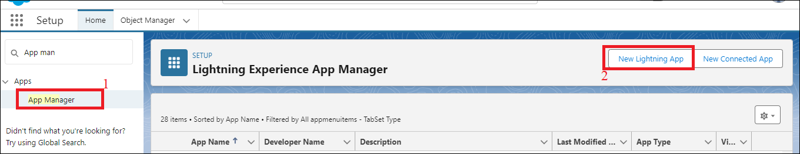

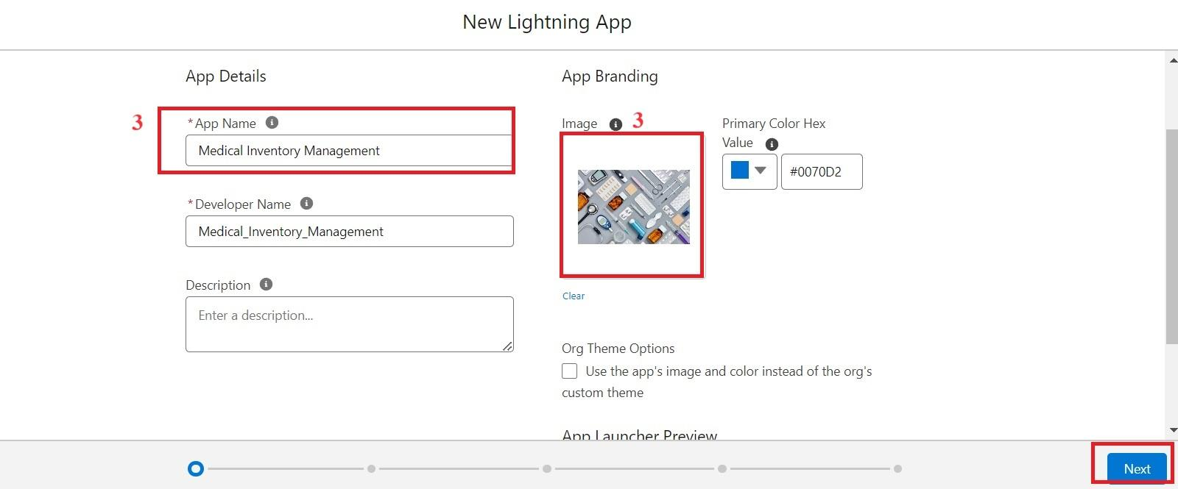

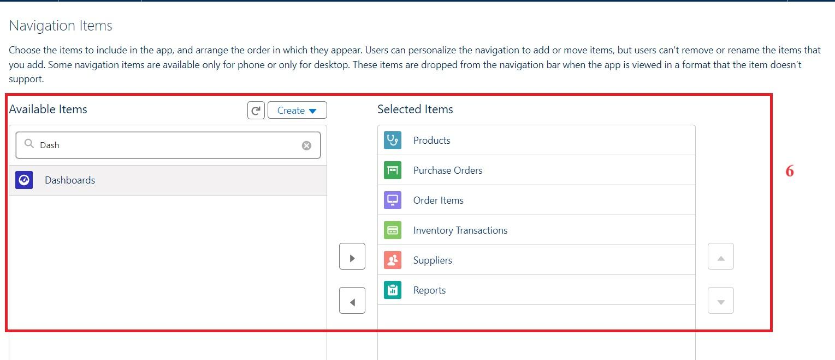

### 

| **Object** | **Field Name** | **Data Type** |
| --- | --- | --- |
| **Product** | Product ID(Standard) | Text |
|  | Product Name | Text |
|  | Product Description | Text Area |
|  | Minimum Stock Level | Number(18, 0) |
|  | Current Stock Level | Number(18, 0) |
|  | Unit Price | Currency(16, 2) |
|  | Expiry Date | Date |
| **Purchase Order** | Purchase Order ID(Standard) | Text |
|  | Supplier ID | Lookup(Supplier) |
|  | Order Date | Date |
|  | Expected Delivery Date | Date |
|  | Actual Delivery Date | Date |
|  | Order Count | Roll-Up Summary (COUNT Order Item) |
|  | Total Order Cost | Currency(16, 2) |
| **Order Item** | Order Item ID(Standard) | Text |
|  | Product ID | Lookup(Product) |
|  | Purchase Order ID | Master-Detail(Purchase Order) |
|  | Quantity Ordered | Number(18, 0) |
|  | Quantity Received | Number(18, 0) |
|  | Unit Price | Formula(Currency) |
|  | Amount | Formula(Currency) |
| **Inventory Transaction** | Transaction ID(Standard) | Text |
|  | Purchase Order ID | Lookup(Purchase Order) |
|  | Transaction Date | Date |
|  | Transaction Type | Picklist |
|  | Total Order Cost | Formula(Currency) |
| **Supplier** | Supplier ID(Standard) | Text |
|  | Supplier Name | Text |
|  | Contact Person | Text |
|  | Phone Number | Phone |
|  | Email | Email |
|  | Address | TextArea |

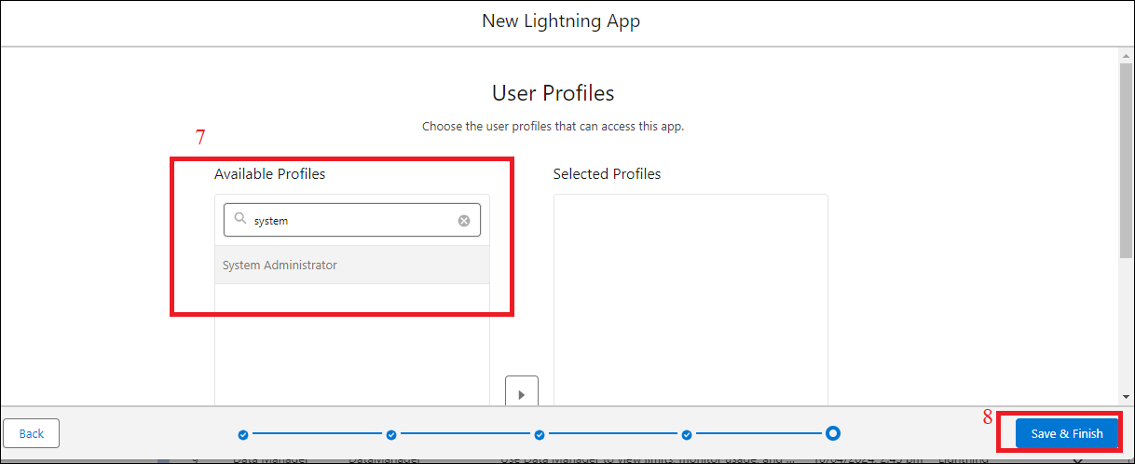

### 

### 

### **Milestone 5- FieldsActivity 1: Creating a Text Field in Product Object**

To create fields in an object:

1. Click the gear icon and select Setup. This launches Setup in a new tab.
2. Click the Object Manager tab next to Home.
3. Select Product custom object.
4. Select Fields & Relationships from the left navigation
5. Click on New
6. Select Text field, click Next
7. Enter Field Label as “Product Name” and Length 255.
8. Select Required Field.
9. Click Next, Next, then Save & New.

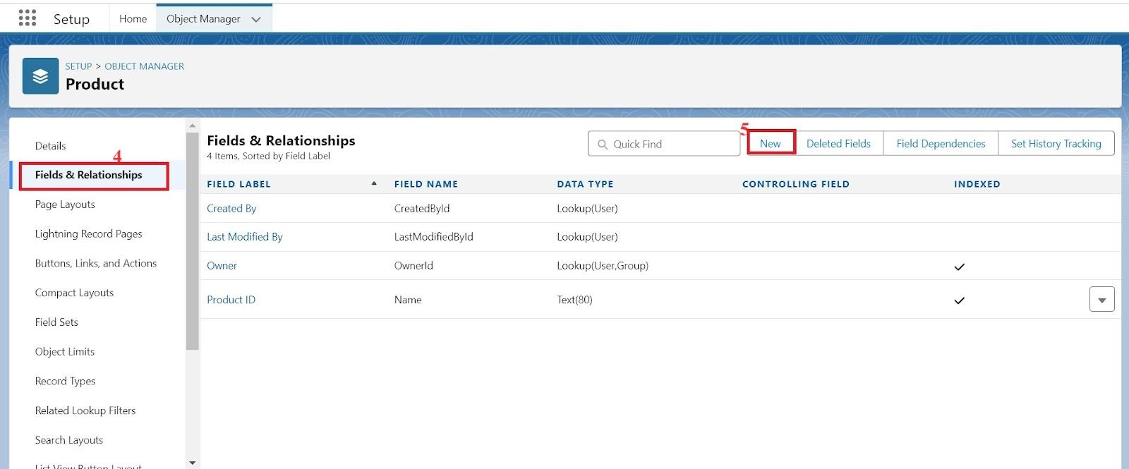

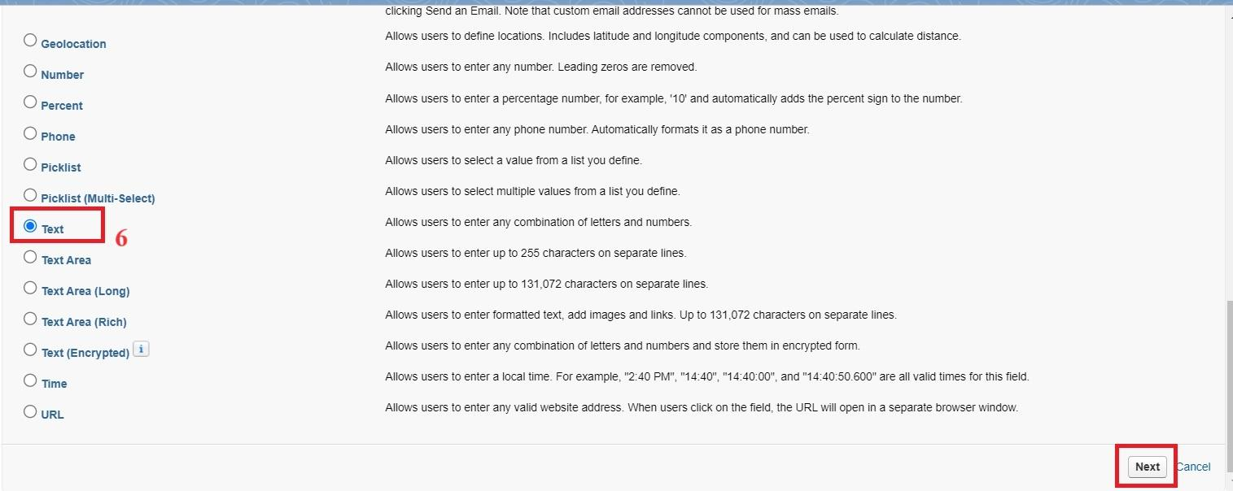

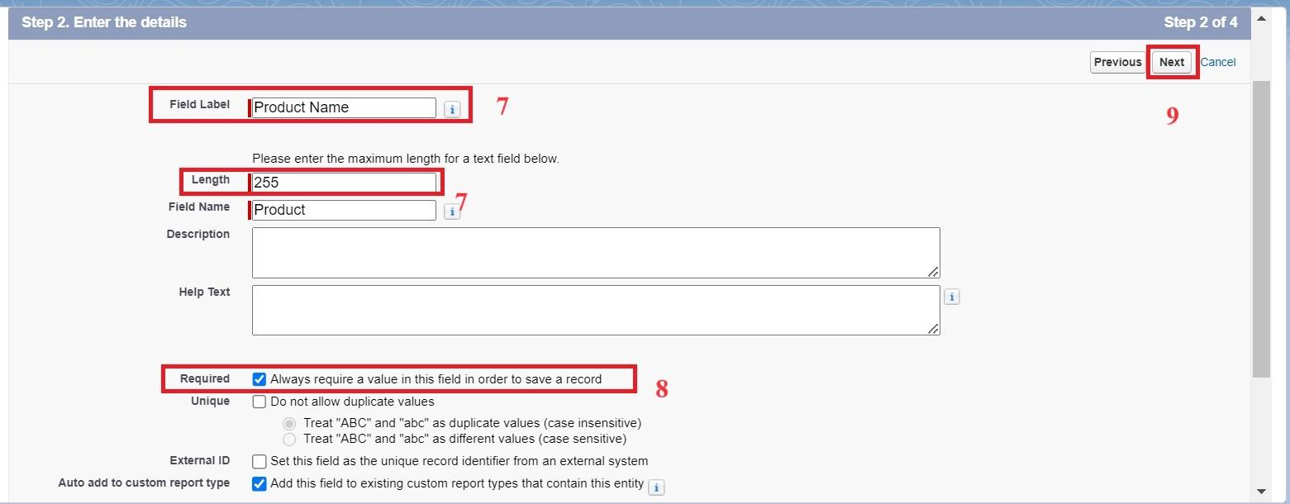

### **Activity 2: Creating a TextArea Field in Product Object**

To create fields in an object:

1. Click the gear icon and select Setup. This launches Setup in a new tab.
2. Click the Object Manager tab next to Home.
3. Select Product custom object.
4. Select Fields & Relationships from the left navigation
5. Click on New
6. Select TextArea field, click Next
7. Enter Field Label as “Product Description” .
8. Click Next, Next, then Save & New.

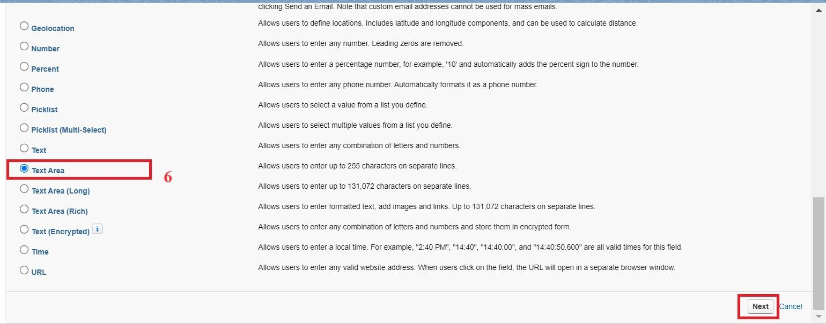

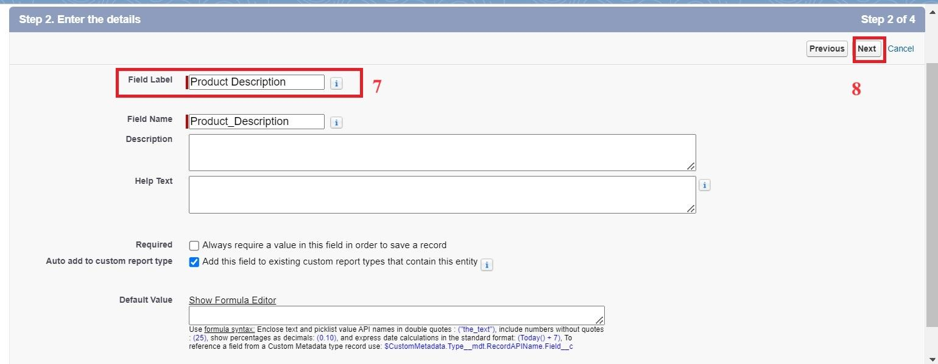

### **Activity 3: Creating a Number Field in Product object**

To create fields in an object:

1. Go to setup >> click on Object Manager >> type object name(Product) in quick find box >> click on the Product custom object.
2. Now click on “Fields & Relationships”
3. Click on New.
4. Select Data type as “Number” and click Next.
5. Enter Field Label as “ Current Stock Level”.
6. Length - 18, Decimal Places - 0.
7. Click on Next, Next and Save.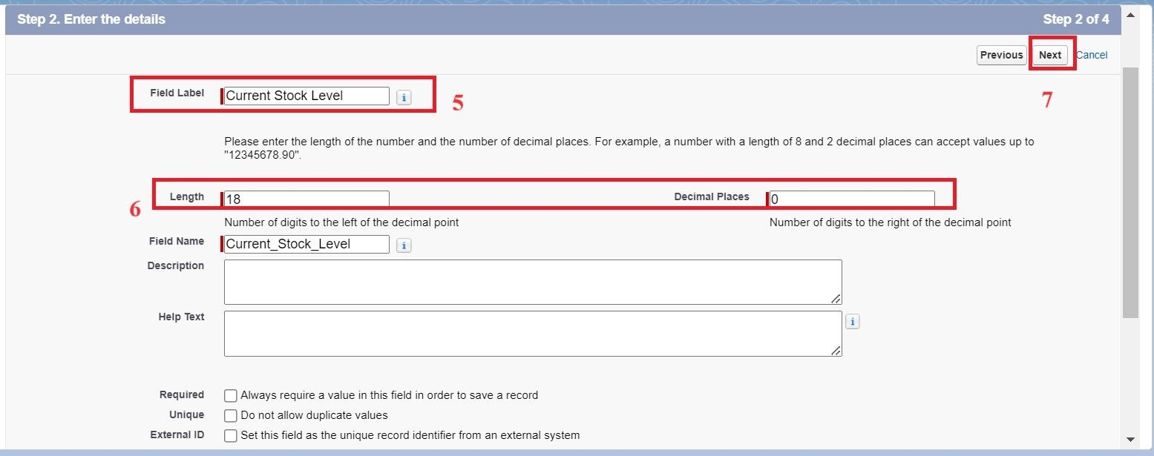

### **Activity 4: Creating a Currency Field in Product object**

To create fields in an object:

1. Go to setup >> click on Object Manager >> type object name(Product) in quick find box >> click on the Product custom object.
2. Now click on “Fields & Relationships”
3. Click on New.
4. Select Data type as “Currency” and click Next.
5. Enter Field Label as “ Unit Price”.
6. Length - 16, Decimal Places - 2.
7. Select Required Field.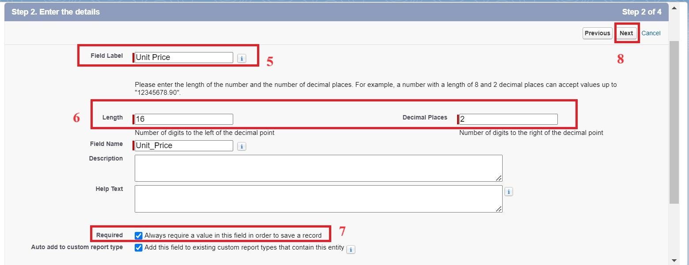
8. Click on Next, Next and Save.

### **Activity 5 : Creating Lookup Relationship in Purchase Order Object**

A Lookup relationship is a type of relationship in Salesforce that connects two objects together based on a field known as the Lookup field. It establishes a relationship between a child object and a parent object, allowing the child object to reference the parent object.

To Create a relationship from Purchase Order to Supplier .

1. Go to the Setup page >> click on Object manager >> type object name(Purchase Order) in the quick find bar >> click on the Purchase Order object.
2. Click on Fields & Relationship
3. Click on New.
4. Select “Lookup relationship” as data type and click Next.
5. Select the related object “ Supplier”.
6. Click on Next.
7. Give Field Label as “Supplier ID” .
8. Select Required Field.
9. Click on Next , Next, Next , Save.

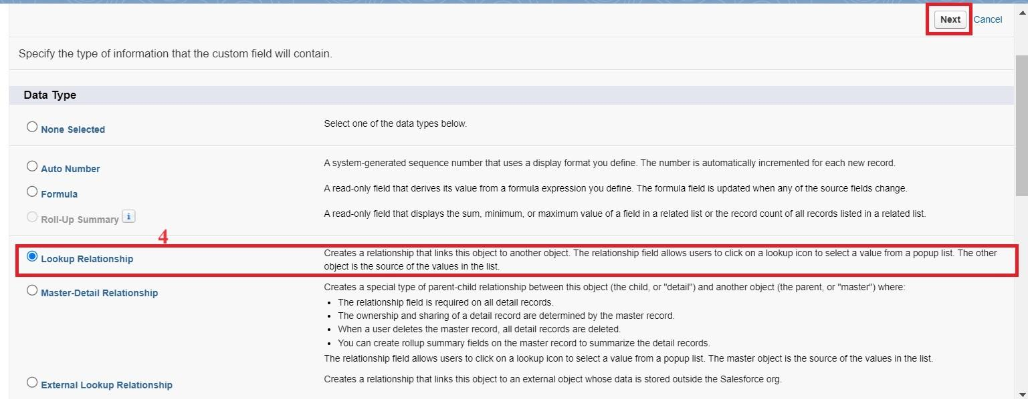

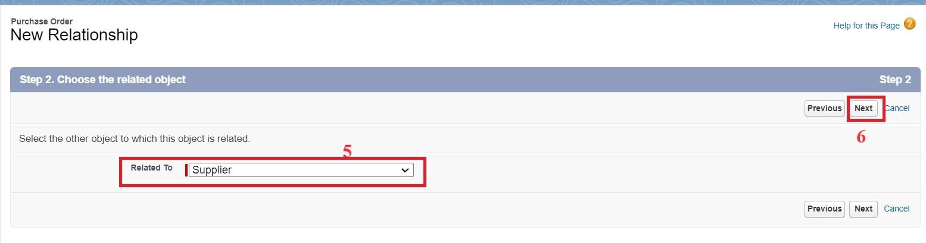

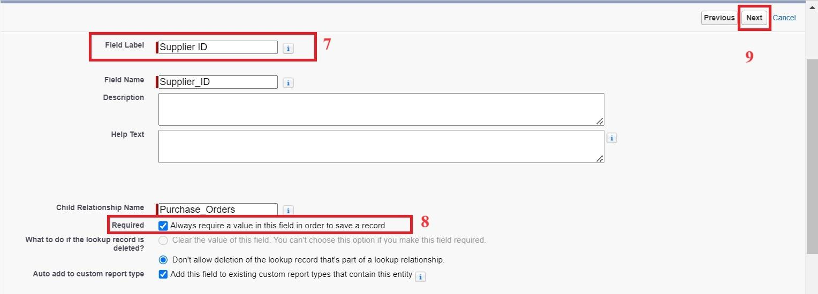

### **Activity 6: Creating a Date Field in Purchase Order object**

To create fields in an object:

1. Go to setup >> click on Object Manager >> type object name(Purchase Order) in quick find box>> click on the Purchase Order object.
2. Now click on “Fields & Relationships”
3. Click on New.
4. Select Data type as “Date” and click Next.
5. Enter Field Label as “ Order Date”.
6. Click on Next, Next and Save.

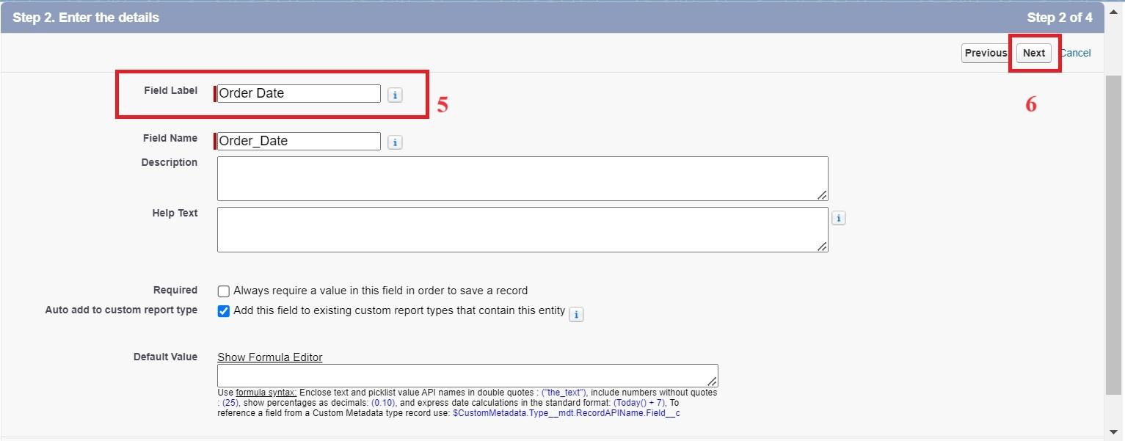

### **Activity 7: Creating a Roll-Up Summary Field in Purchase Order object**

To create fields in an object:

1. Go to setup >> click on Object Manager >> type object name(Purchase Order) in quick find box>> click on the Purchase Order object.
2. Now click on “Fields & Relationships”
3. Click on New.
4. Select Data type as “Roll-Up Summary” and click Next.
5. Enter Field Label as “ Order Count”.
6. Choose the Summarized Object as “Order Items”.
7. For Select Roll-Up Type select “Count”.
8. Click on Next, Next and Save.

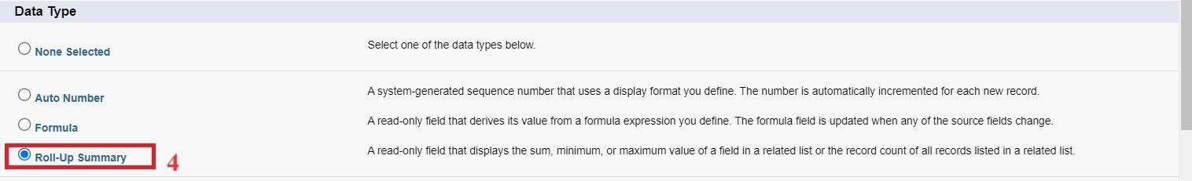

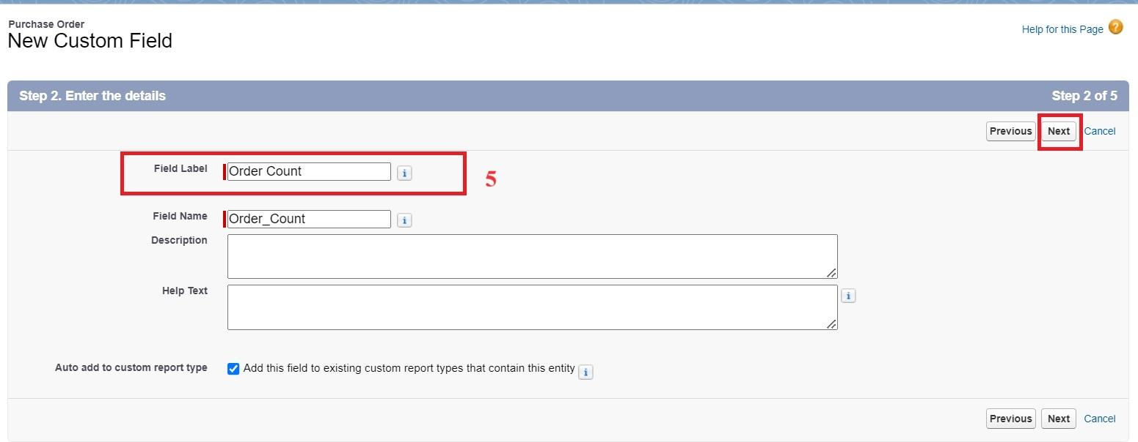

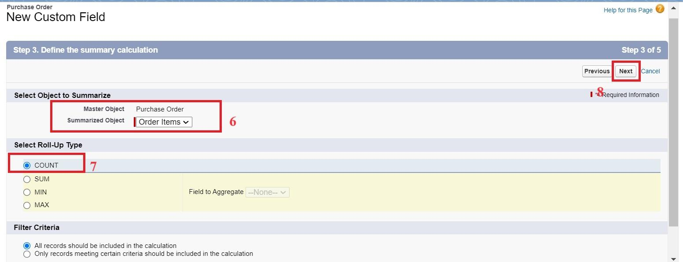

### **Activity 8: Creating a Unit Price Formula Field in Order Item object**

To create fields in an object:

1. Go to setup >> click on Object Manager >> type object name(Order Item) in quick find box >> click on the Order Item object.
2. Now click on “Fields & Relationships”
3. Click on New.
4. Select Data type as “Formula” and click Next.
5. Enter field label Unit Price.
6. Select formula return type Currency, Click Next
7. Create and insert Advance formula: Product_ID__r.Unit_Price__c
8. Click Next, Next, then Save.

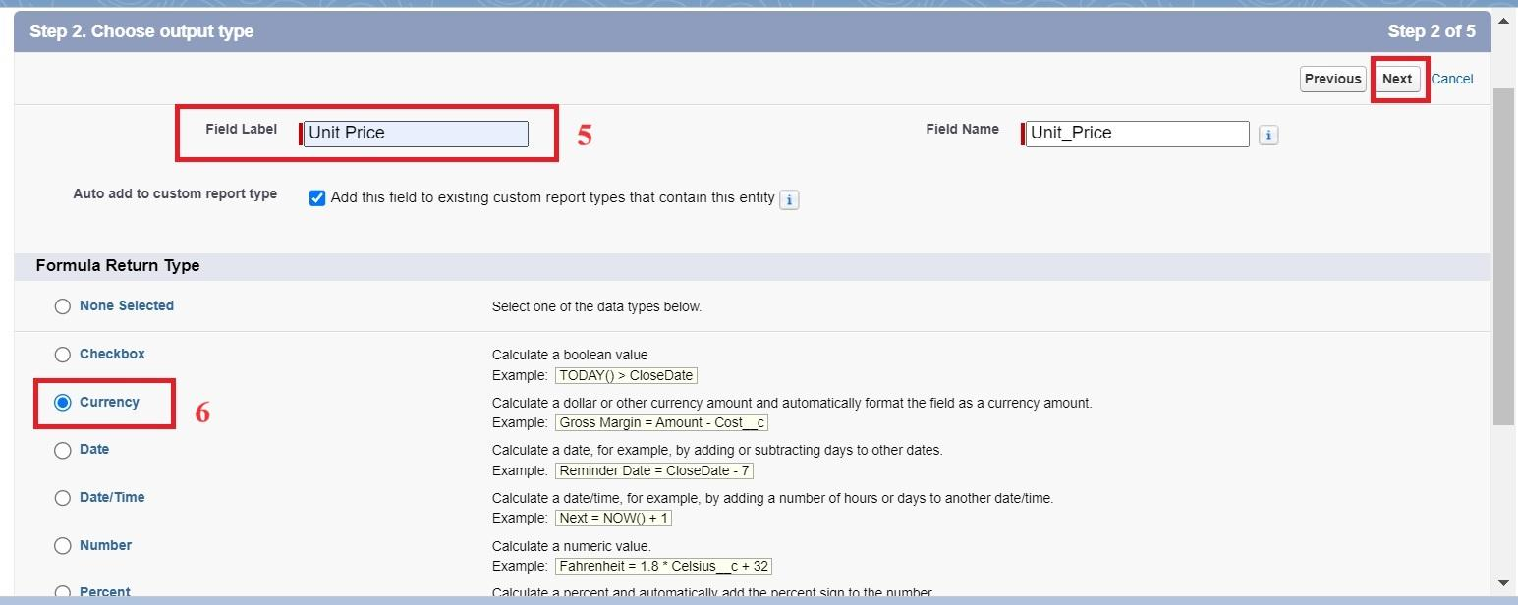

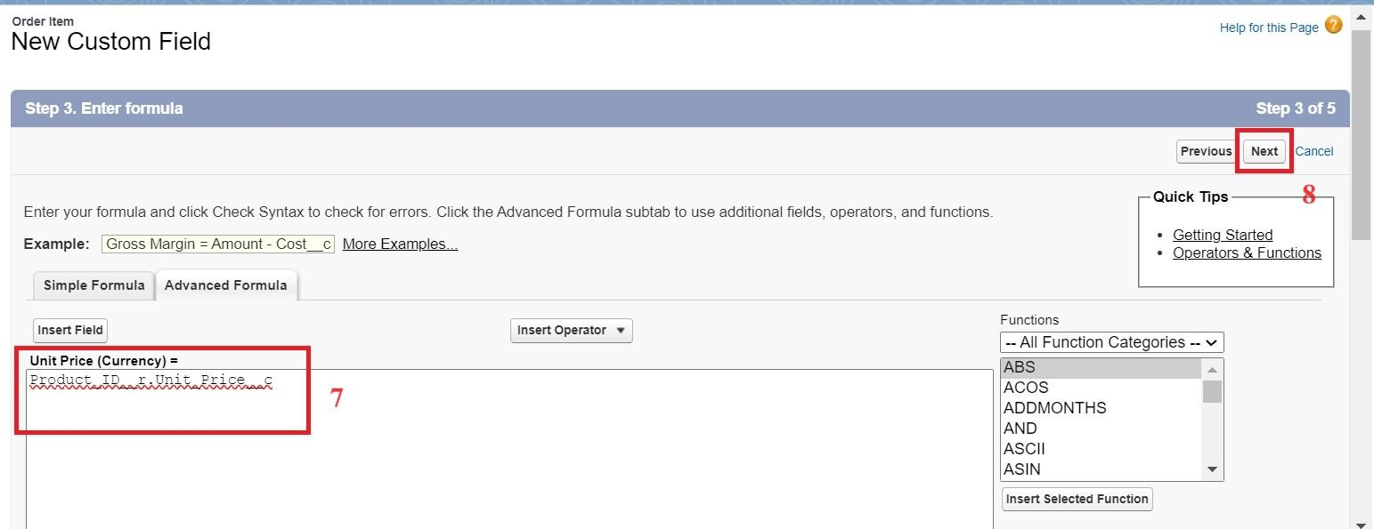

### **Activity 9: Creating a Amount Formula Field in Order Item object**

To create fields in an object:

1. Go to setup >> click on Object Manager >> type object name(Order Item) in quick find box >> click on the Order Item object.
2. Now click on “Fields & Relationships”
3. Click on New.
4. Select Data type as “Formula” and click Next.
5. Enter field label Amount.
6. Select formula return type Currency, Click Next
7. Create and insert Advance formula: Quantity_Received__c * Unit_Price__c
8. Click Next, Next, then Save.

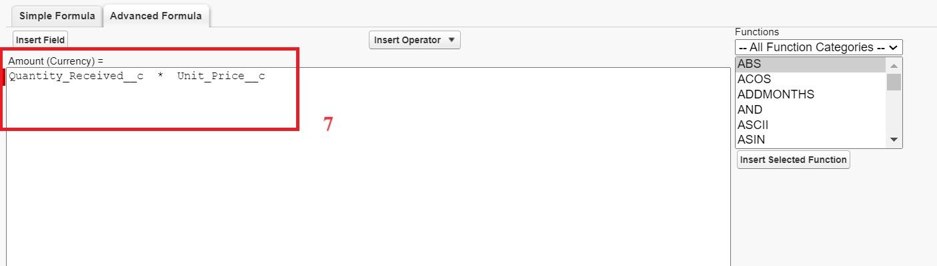

### **Activity 10: Creating a Picklist Field in Inventory Transaction Object**

To create fields in an object:

1. Go to setup >> click on Object Manager >> type object name(Inventory Transaction) in quick find box>> click on the Inventory Transaction Object.
2. Now click on “Fields & Relationships” .
3. Click on New.
4. Select Data type as “Picklist” and click Next.
5. Enter Field Label as “Transaction Type”.
6. In values select “Enter values, with each value separated by a new line" and enter values as shown below.

Receipt

Issue

Adjustment

1. Click on Next, Next and Save.

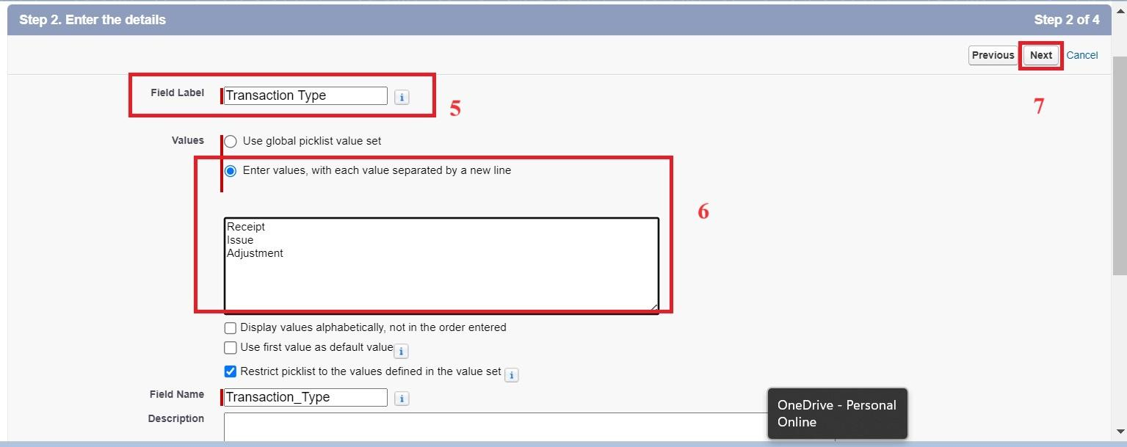

### **Activity 11: Creating a Total Order Cost Formula Field in Inventory Transaction object**

To create fields in an object:

1. Go to setup >> click on Object Manager >> type object name(Inventory Transaction) in quick find box >> click on the Order Item object.
2. Now click on “Fields & Relationships”
3. Click on New.
4. Select Data type as “Formula” and click Next.
5. Enter field label Total Order Cost.
6. Select formula return type Currency, Click Next
7. Create and insert Advance formula: Purchase_Order_ID__r.Total_Order_Cost__c
8. Click Next, Next, then Save.

### **Activity 12: Creating a Phone Field in Supplier object**

To create fields in an object:

1. Go to setup >> click on Object Manager >> type object name(Supplier) in quick find box>> click on the Supplier object.
2. Now click on “Fields & Relationships”
3. Click on New.
4. Select Data type as “Phone” and click Next.
5. Enter the Field Label as “ Phone Number”.
6. Select Required Field.
7. Click on Next, Next and Save.

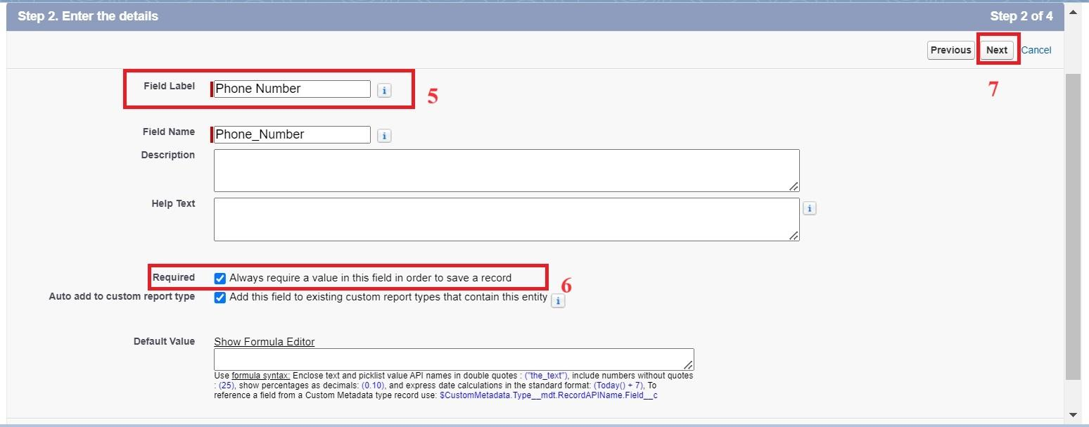

### **Activity 13: Creating a Email Field in Supplier object**

To create fields in an object:

1. Go to setup >> click on Object Manager >> type object name(Supplier) in quick find box>> click on the Supplier object.
2. Now click on “Fields & Relationships”
3. Click on New.
4. Select Data type as “Email” and click Next.
5. Enter the Field Label as “ Email”.
6. Click on Next, Next and Save.

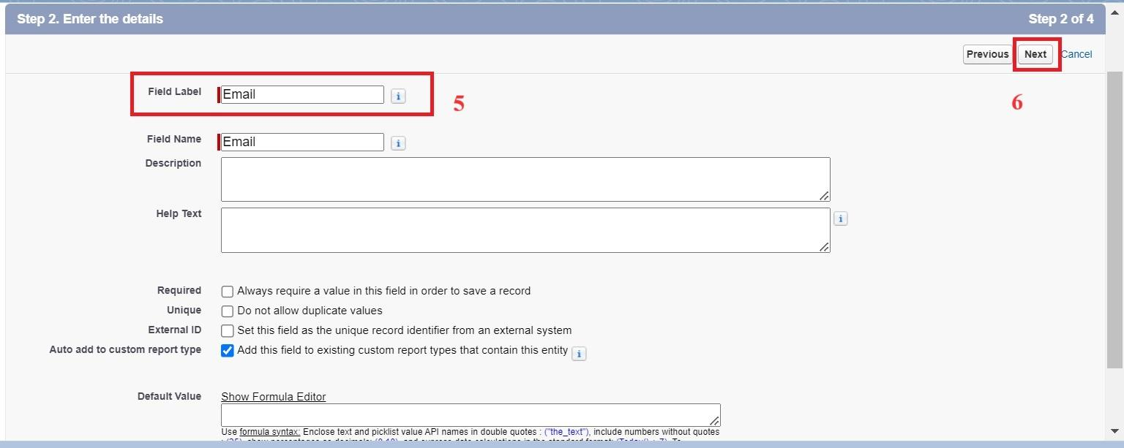

### 

### **Milestone 6 -Editing of Page Layouts**

Page layouts in Salesforce are used to customize the organization, structure, and content of pages for viewing and editing records. They determine which fields, related lists, and custom links are visible to users, as well as the order and grouping of those elements.

### **Activity 1: To edit a Page Layout in Product Object**

1. Go to setup >> click on Object Manager >> type object name(Product) in quick find box >> click on the Product object >> Page Layouts .
2. Click on the Product Layout.
3. Drag and Arrange the field as shown below.

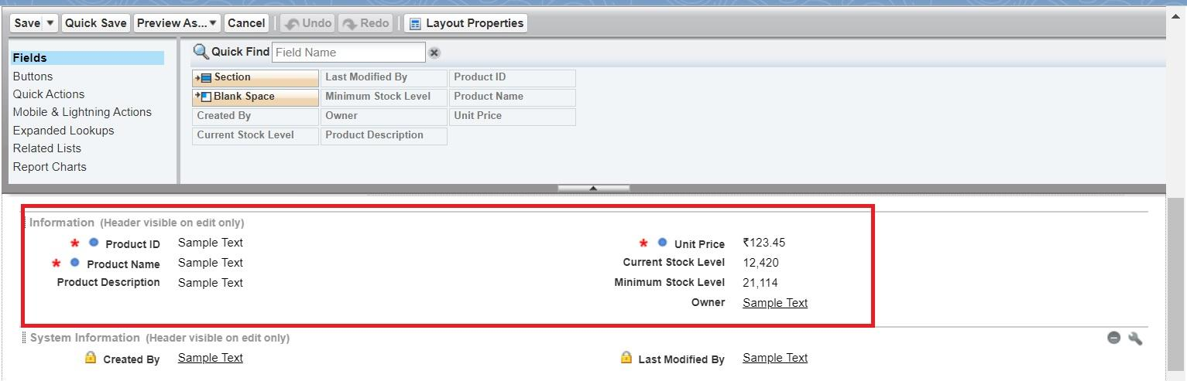

1. Click on Save.

### **Activity 2: To edit a Page Layout in Purchase Order Object**

1. Go to setup >> click on Object Manager >> type object name(Purchase Order) in quick find box >> click on the Purchase Order object >> Page Layouts.
2. Click on the Purchase Order Layout
3. Drag and Arrange the field as shown below

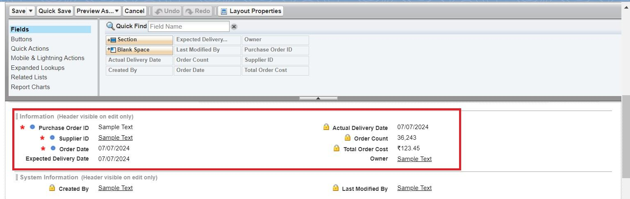

1. Click on field Order Date >> click on settings >> select Required and save it.
2. Click on field Total Order Cost >> click on settings >> select Read Only and save it.
3. Click Save.

### **Activity 3: To edit a Page Layout in Order Item Object**

1. Go to setup >> click on Object Manager >> type object name(Order Item) in quick find box >> click on the Order Item object >> Page Layouts.
2. Click on the Order Item Layout
3. Drag and Arrange the field as shown below

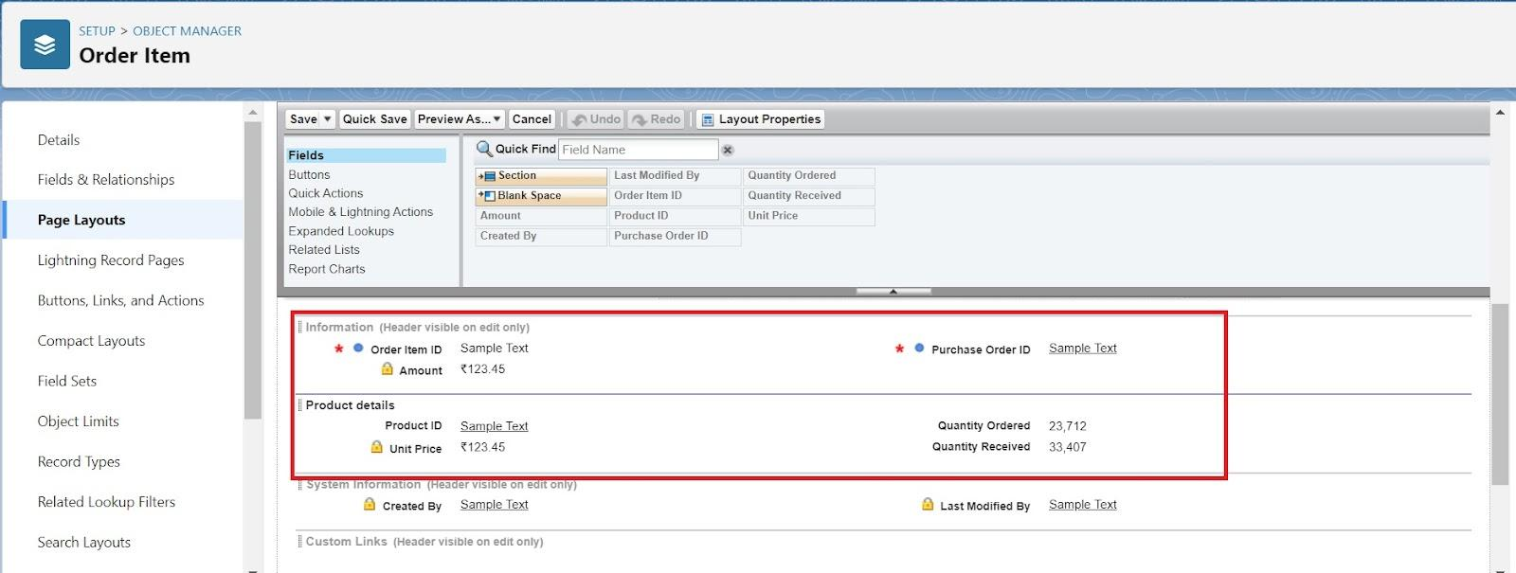

1. Click Save.

### 

### 

### **Activity 4: To edit a Page Layout in Inventory Transaction Object**

1. Go to setup >> click on Object Manager >> type object name(Inventory Transaction) in quick find box >> click on the Inventory Transaction object >> Page Layouts.
2. Click on the Inventory Transaction Layout
3. Drag and Arrange the field as shown below

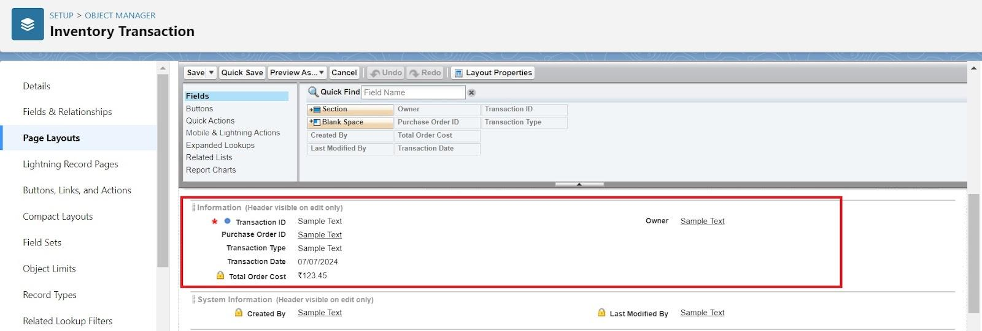

1. Click Save.

### **Activity 5: To edit a Page Layout in Supplier Object**

1. Go to setup >> click on Object Manager >> type object name(Supplier) in quick find box >> click on the Supplier object >> Page Layouts.
2. Click on the Supplier Layout
3. Drag and Arrange the field as shown below

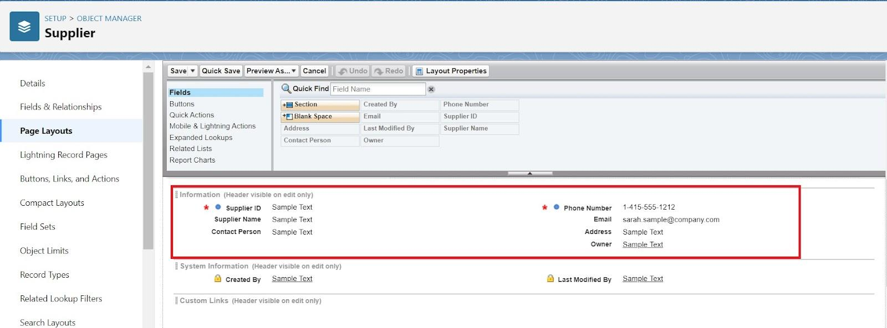

1. Click Save.

### **Milestone 7 - Compact Layouts**

Compact layouts display a record’s key fields at a glance, providing important information quickly without needing to open the record.

### **Activity 1: To create a Compact Layout to a Product Object**

1. Go to setup >> click on Object Manager >> type object name(Product) in quick find box >> click on the Product object
2. Click on Compact Layouts in the sidebar .
3. Click on New.
4. Enter the Label as “Product Compact Layout”.
5. Select the Compact Layout Fields : Select Product name, Unit Price, Current Stock Level.
6. Click Save.
7. Click Compact Layout Assignment.
8. Click Edit Assignment.
9. Choose "Product Compact Layout" from the dropdown.
10. Click Save.

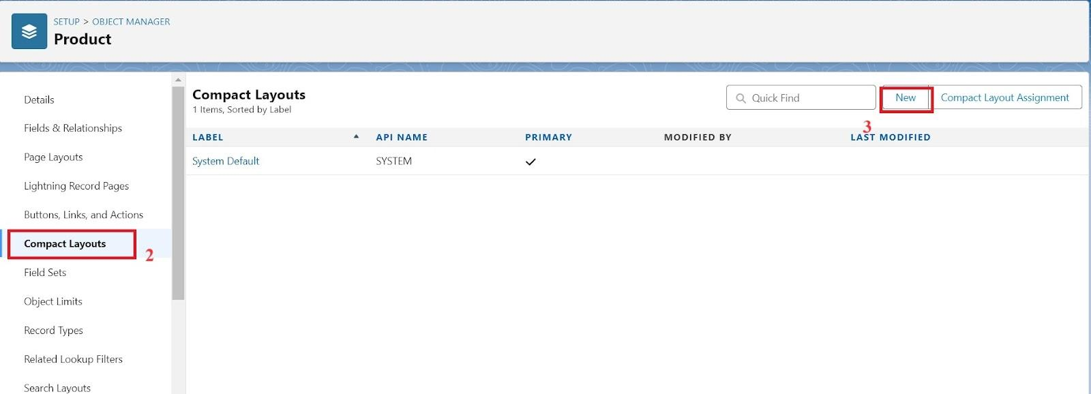

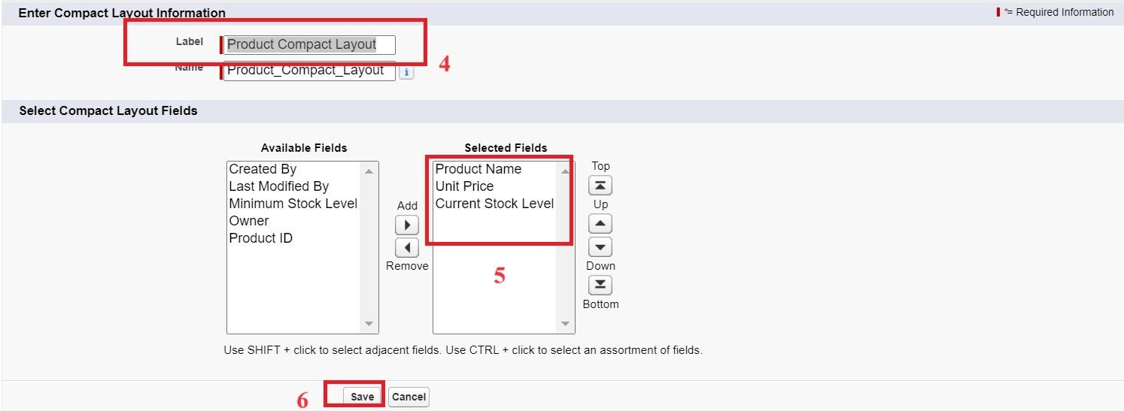

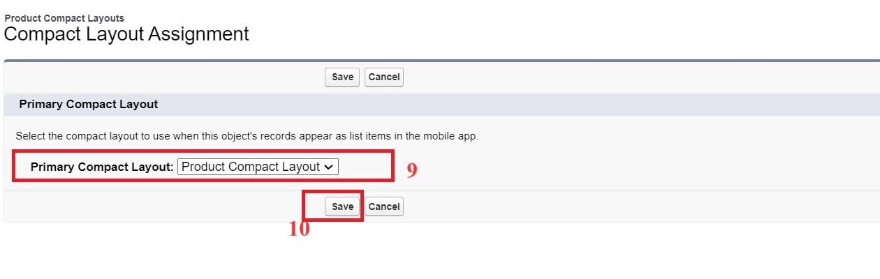

### **Activity 2: To create a Compact Layout to a Purchase Order Object**

1. Go to setup >> click on Object Manager >> type object name(Purchase Order) in quick find box >> click on the Purchase Order object
2. Click on Compact Layouts in the sidebar .
3. Click on New.
4. Enter the Label as “Purchase Order Compact Layout”.
5. Select the Compact Layout Fields : Select Purchase Order ID, Order Date, Total Order Cost, Supplier ID.
6. Click Save.
7. Click Compact Layout Assignment.
8. Click Edit Assignment.
9. Choose "Purchase Order Compact Layout" from the dropdown.
10. Click Save.

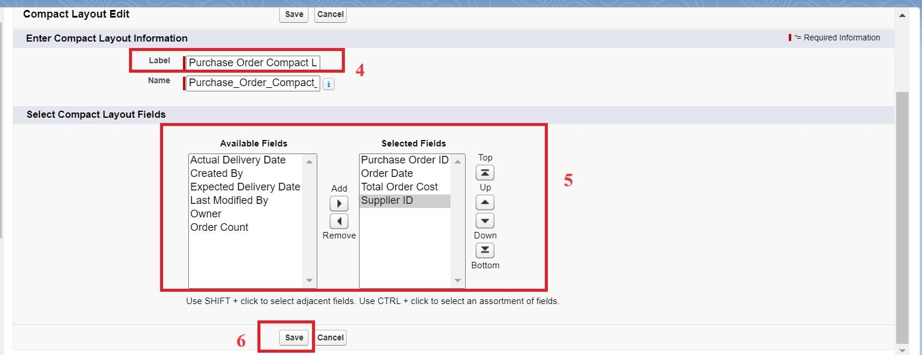

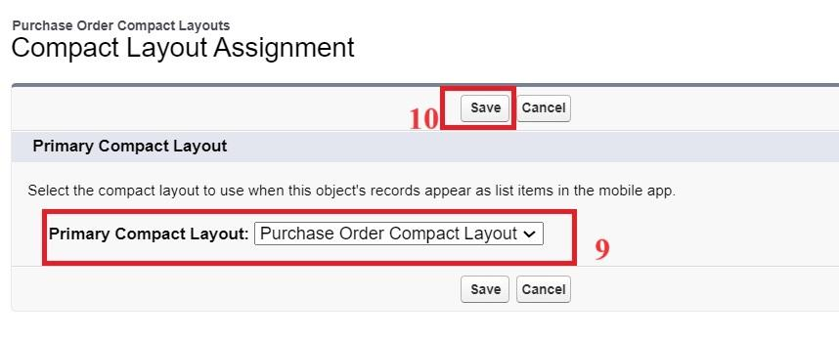

### 

### 

### **Milestone 8 - Validation Rules**

Validation rules in Salesforce are used to ensure data integrity by preventing users from saving invalid data in records. They consist of a formula or expression that evaluates the data in one or more fields and return a value of true or false. When the rule's criteria are met (i.e., the expression evaluates to true), an error message is displayed, and the user is prevented from saving the record until the issue is resolved.

### **Activity 1: To create an Expected Delivery Date Validation rule to a Employee Object**

1. Go to setup >> click on Object Manager >> type object name(Purchase Order) in quick find box>> click on the Purchase Order object
2. Click on the validation rule >> click on New.
3. Enter the Rule name as “Expected Delivery Date Validation”.
4. Select Active
5. Insert the Error Condition Formula as :  
   (Expected_Delivery_Date__c - Order_Date__c )> 7

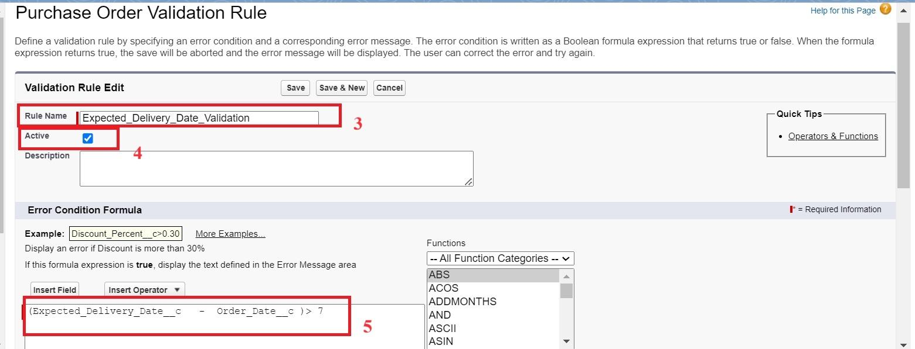

1. Enter the Error Message as “The Expected Delivery Date should not exceed 7 days.”.
2. Select the Error location as Top of Page
3. Click Save.

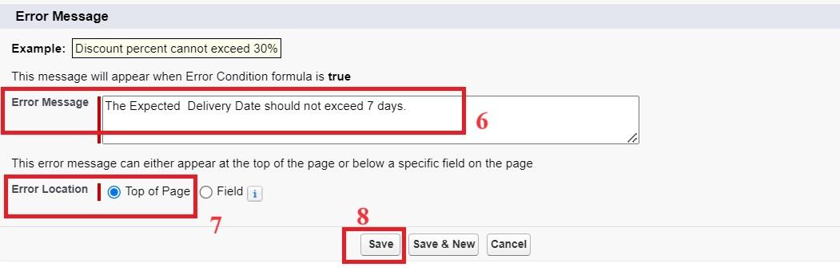

### **Milestone 9 - Profiles:**

Profiles in Salesforce are fundamental to the platform's security model, defining what users can do within the organization. Profiles control a user’s permissions to objects, fields, tabs, apps, and other settings. Each user in Salesforce must be assigned a profile, and the profile assigned to a user determines what they can see and do in the system.

### **Activity 1: To create an Inventory Manager Profile**

1. Go to setup >> type profiles in quick find box >> click on profiles >> clone the desired profile (Standard User) >> enter profile name (Inventory Manager) >> Save.

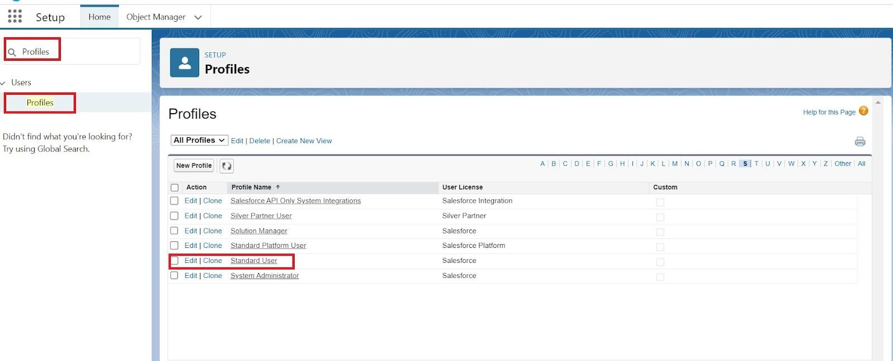

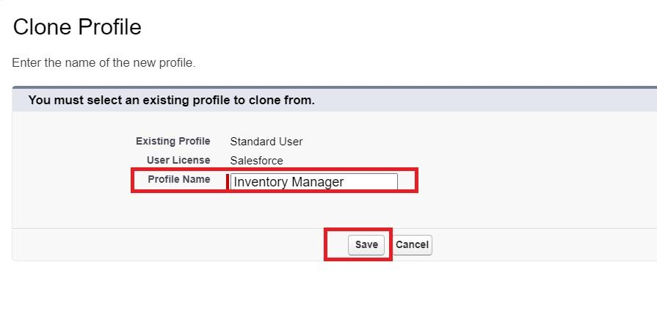

1. While still on the profile page, then click Edit.
2. Select the Custom App settings as default for the Medical Inventory Management.

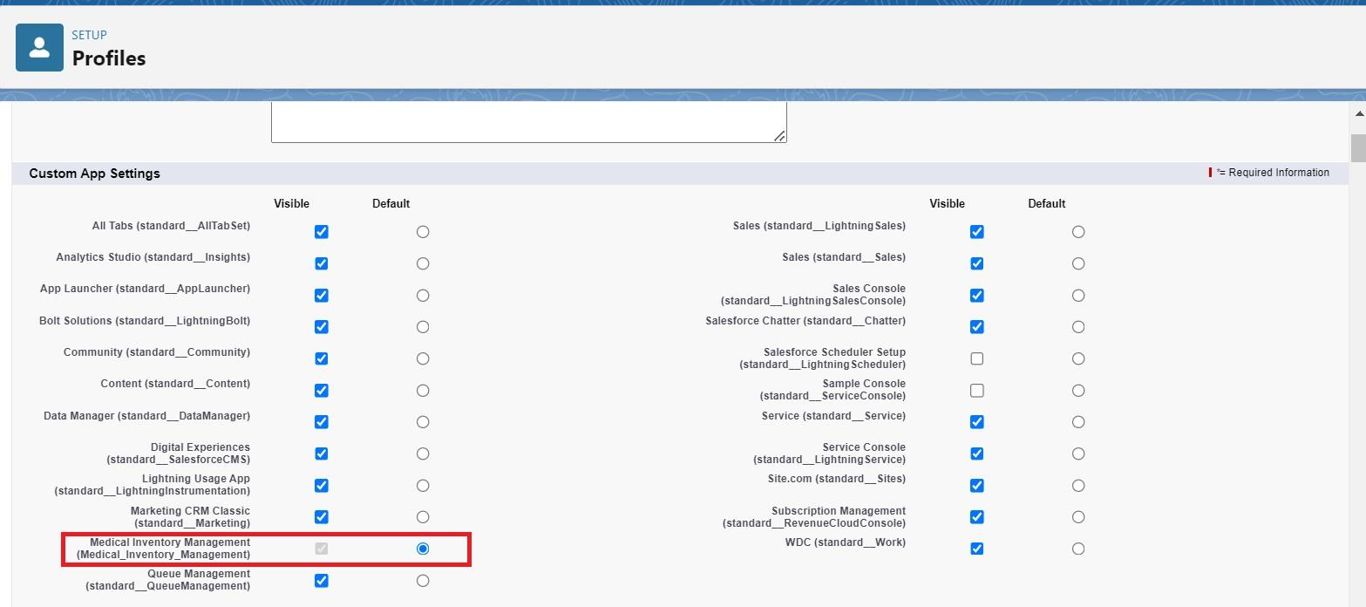

1. Scroll down to Custom Object Permissions and Give access permissions as mentioned in the below diagram.

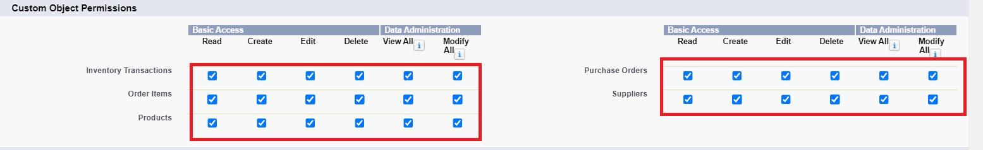

1. Change the password policies as mentioned :
2. User passwords expire in should be “ never expires ”.
3. Minimum password length should be “ 8 ”, and click save.

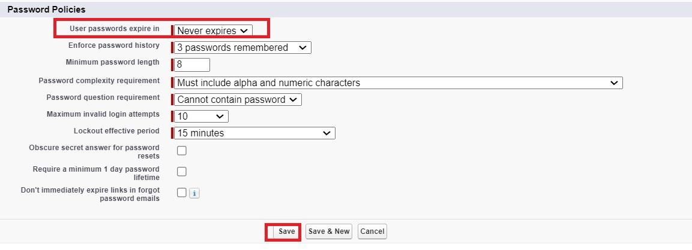

### **Activity 2: To create an Purchase Manager Profile**

1. Go to setup >> type profiles in quick find box >> click on profiles >> clone the desired profile (Standard User) >> enter profile name (Purchase Manager) >> Save.
2. While still on the profile page, then click Edit.
3. Select the Custom App settings as default for the Medical Inventory Management.

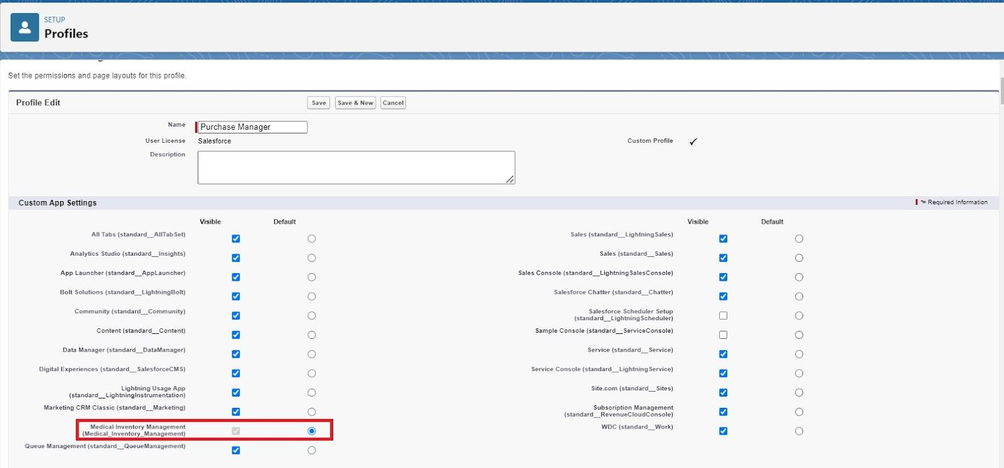

1. Scroll down to Custom Object Permissions and Give access permissions as mentioned in the below diagram.

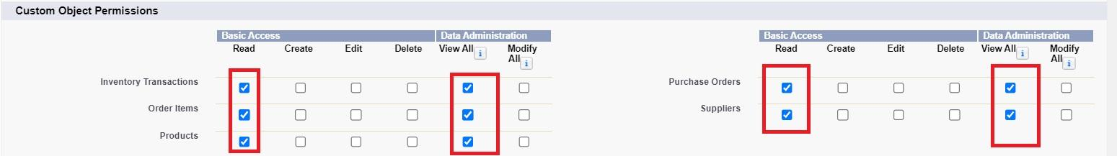

1. Change the password policies as mentioned :
2. User passwords expire in should be “ never expires ”.
3. Minimum password length should be “ 8 ”, and click save.



### **Milestone 10 - Roles**

Roles in Salesforce are used to control record-level access and define the hierarchy of an organization, determining the level of visibility and sharing of records among users. Roles work in conjunction with profiles to provide a robust security model. While profiles control what actions users can perform (object and field permissions), roles control which records users can see based on their position in the hierarchy.

### **Activity 1 : Create a Purchasing Manager Role.**

1. Go to quick find >> Search for Roles >> click on Set Up Roles.

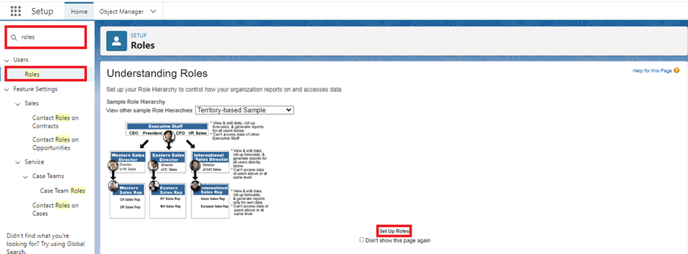

1. Click on Expand All and click on add role under SVP, Sales & Marketing role.
2. Give Label as “Purchasing Manager” and Role name gets auto populated. Then click on Save.

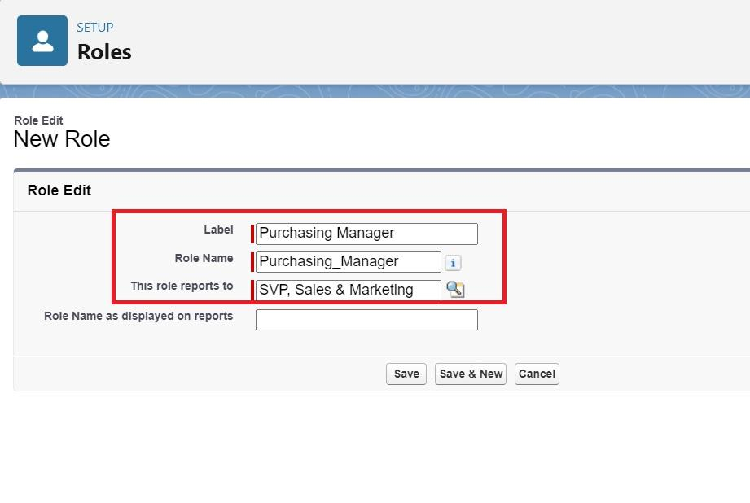

### **Activity 2 : Create a Purchasing Manager Role.**

1. Go to quick find >> Search for Roles >> click on Set Up Roles.



1. Click on Expand All and click on add role under SVP, Sales & Marketing role.
2. Give Label as “Inventory Manager” and the Role name gets auto populated. Then click on Save.

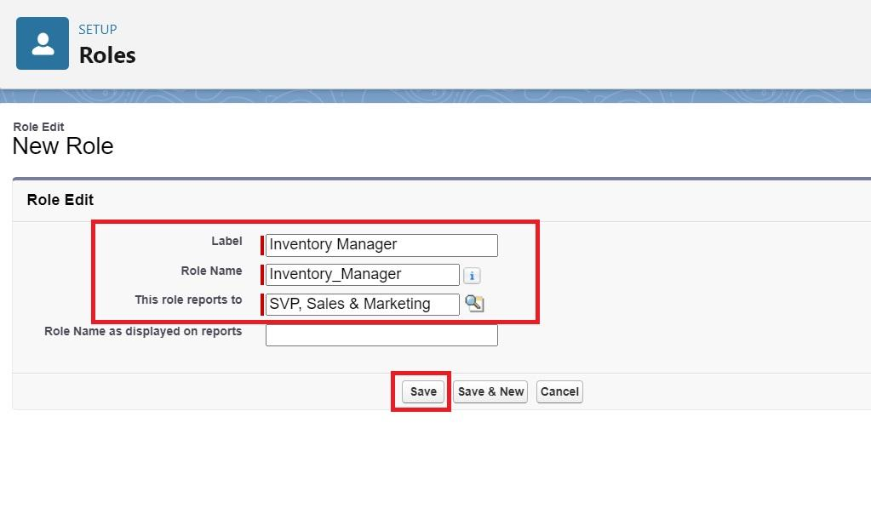

### **Milestone 12 - Permission Sets**

Permission Sets in Salesforce are a powerful tool to extend user permissions beyond what is defined in their profiles. They allow administrators to grant additional access to various tools and functions without altering the user's profile. Permission sets are particularly useful for providing specialized permissions to specific users without the need to create multiple profiles.

### **Activity 1 : Create a Permission Set.**

1. Go to setup >> type Permission in quick find box >> Select Permission Set >> click on New.

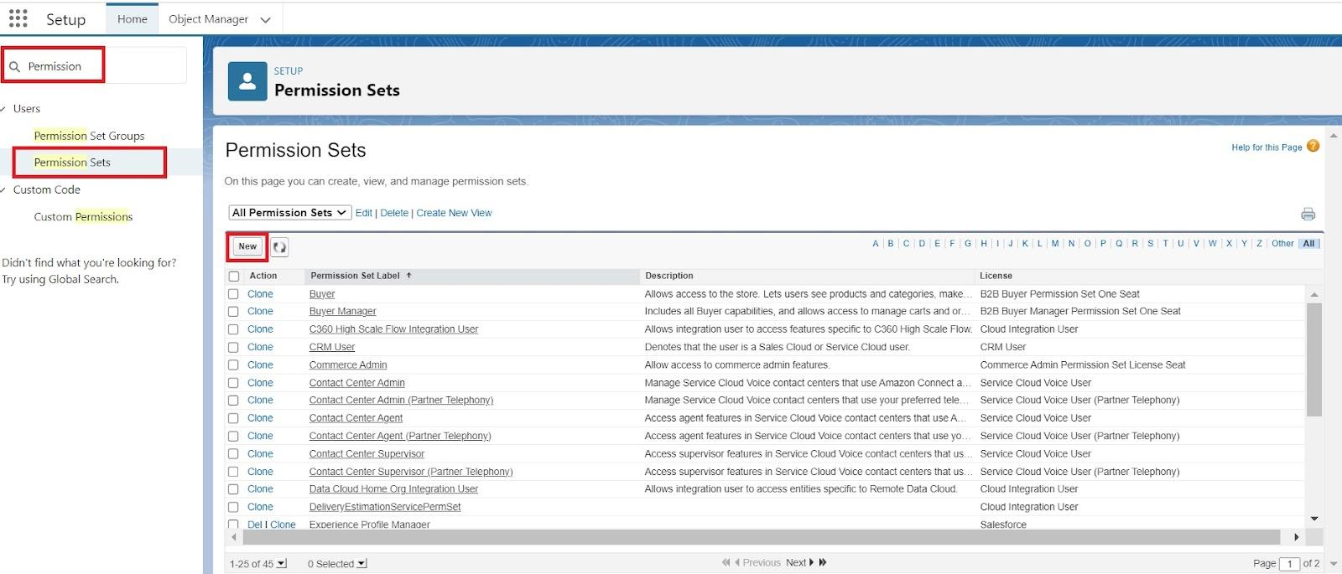

1. Enter Label as Purchase Manager Create Access >> Click on Save.

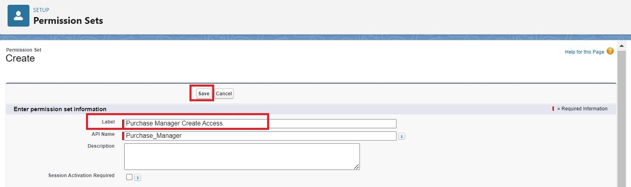

1. From Object Settings >> Select Order Item >> Enable for both Tab Available and Visible >> Enable Read and Create in Object Permissions >> Click on Save.

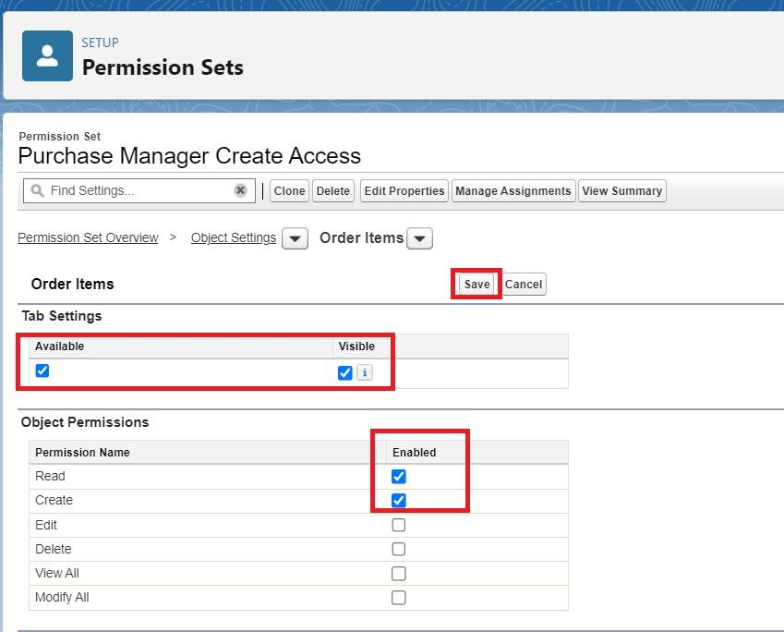

1. Navigate to the Permission Set detail page >> Click Manage Assignments >> Click Add Assignments >> Select the user John PurchaseM to assign the permission set to and click Next.

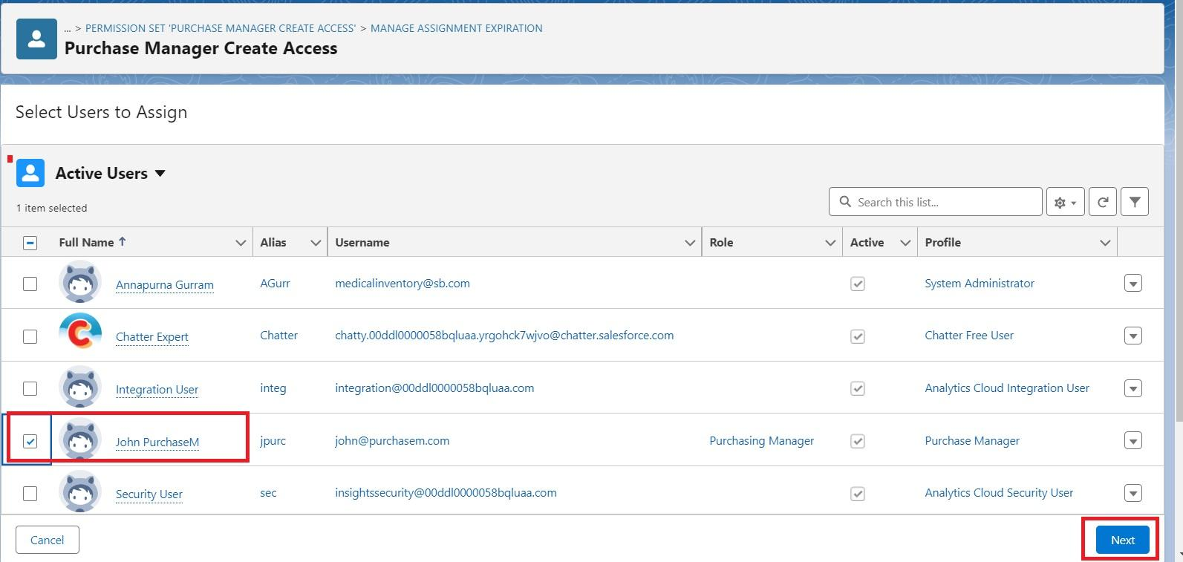

1. Select No Expiration date >> Click on Assign.

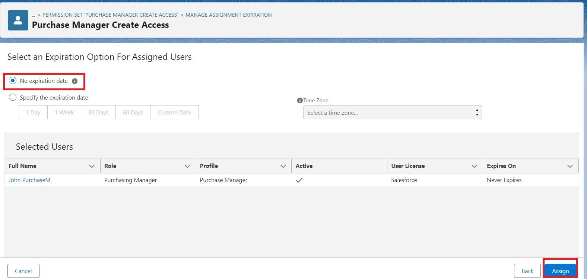

### **Milestone 13 - Flows**

Flows in Salesforce, part of the Lightning Flow product, are powerful automation tools that help you collect data and perform actions in your Salesforce environment. Flows can be used to automate business processes, guide users through tasks, and integrate with external systems. They are highly versatile and can be configured to meet a wide range of business requirements without the need for custom code.

### **Activity 1 : Create Flow to update the Actual Delivery Date.**

1. Go to setup >> type Flow in quick find box >> Click on the Flow and Select the New Flow >> Start From Scratch .

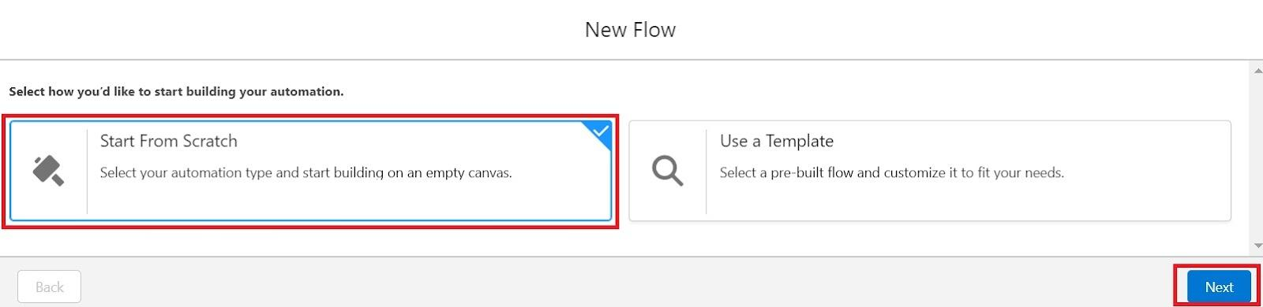

1. Select the record Triggered flow.Click on create.

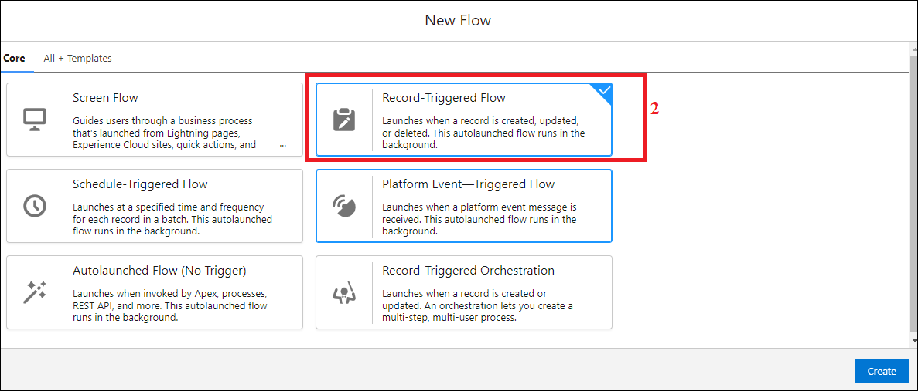

1. Under Object select “Purchase Order”
2. Select A record is created or updated

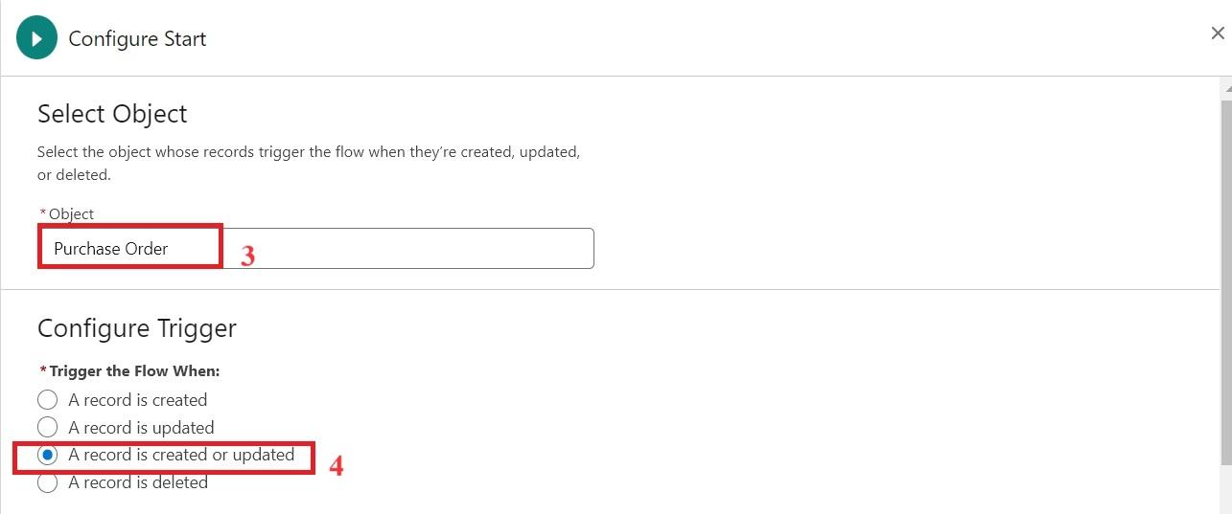

1. Set Entry Conditions : None
2. Select Fast Field Updates and click on Done

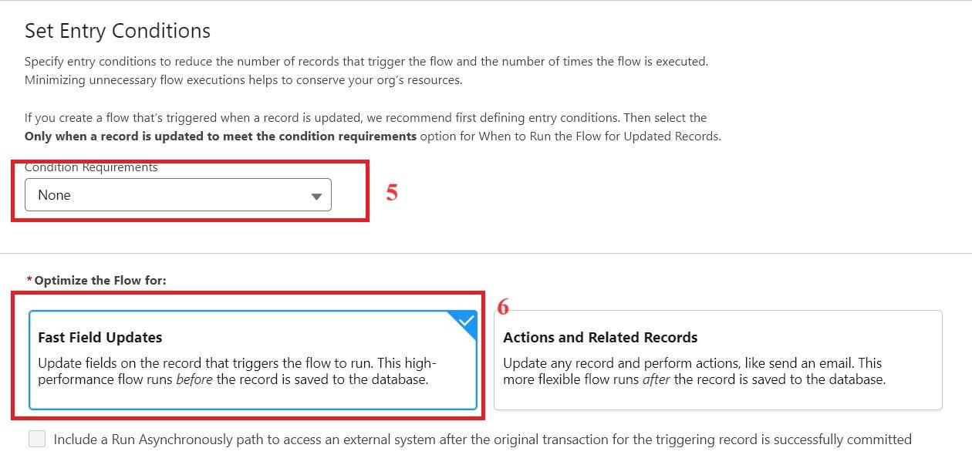

1. Under the record trigger flow click on the “+” icon and select Get Records.
2. Enter Label as “ Get Purchase Record ”.
3. For Object select Purchase Order.
4. For Condition Requirements , select All Conditions are Met(AND)

For the first condition select as follows:

Field: Id

Operator: Equals

Value: {!$Record.Id}

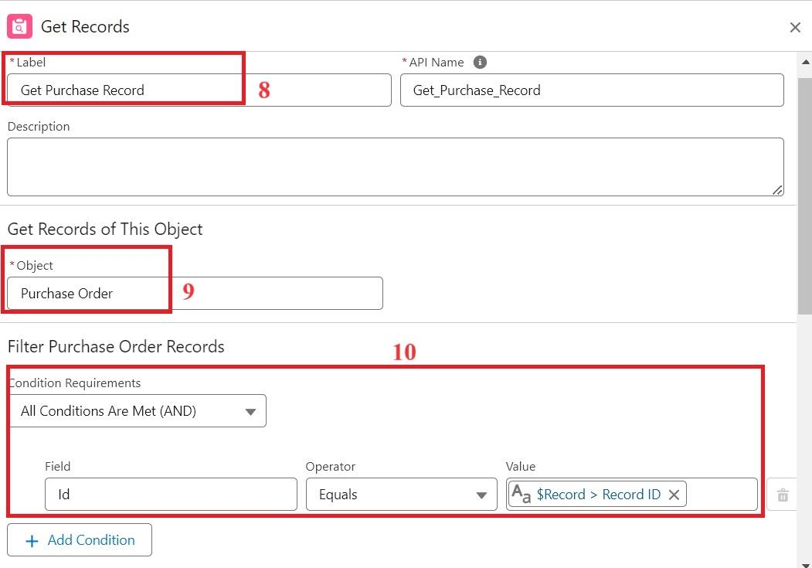

1. For How many Records to store Select Only the First Record.
2. For How to Store Record Data select Choose fields and let Salesforce do the rest. Select Field: Order_Date__c. Click on Done.

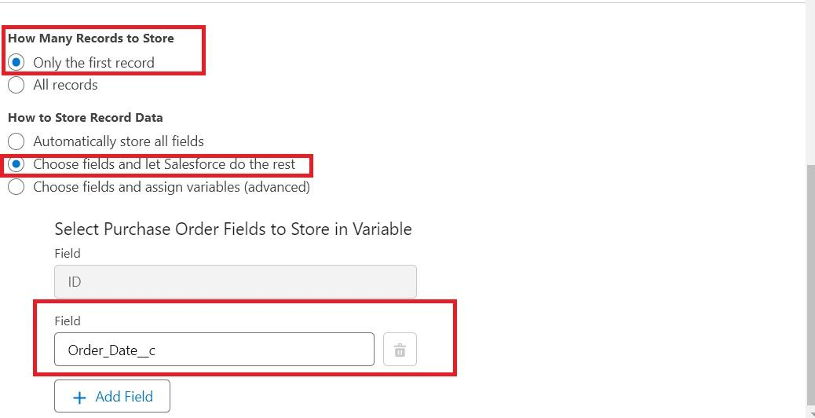

1. In the Flow Builder, click on the Manager tab on the left-hand side >> Click on New Resource >> In the Resource Type dropdown, select Variable.
2. Enter API name as ActualDeliveryDate >> Select Data type as Date >> Click on Done.
3. From the Toolbox drag and drop Assignment element.
4. Enter the label as “Assignment”.
5. Set Variable Values:

a) Variable : {!ActualDeliveryDate}

Operator : Equals

Value : {!$Record.Order_Date__c}

b) Variable : {!ActualDeliveryDate}

Operator : Add

Value : 3

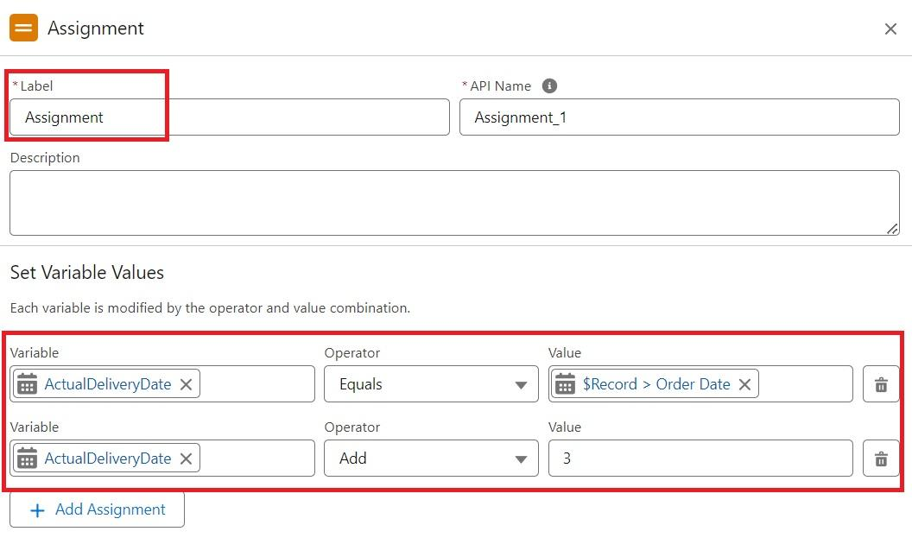

1. Click Done
2. From the Toolbox drag and drop Update Records element and connect to the Assignment element.
3. Enter the label as “Updating Purchasing Order”.
4. How to Find Records to Update and Set Their Values : Use the Purchase Order record that triggered the flow
5. Set Filter Conditions : None -Always Update Record
6. Set Field Values for the Trip Record as

Field : Actual_Delivery_Date__c

Value : {!ActualDeliveryDate}

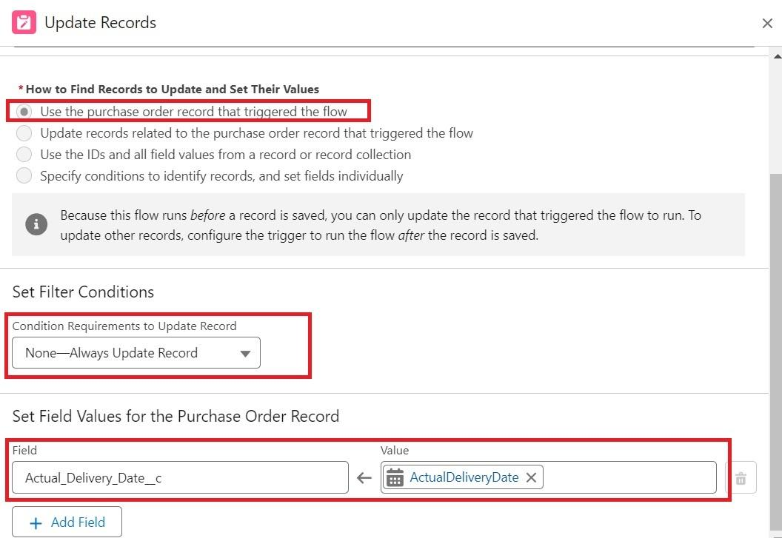

1. Click Done
2. Save the flow as “Actual Delivery Date Updating”.
3. Activate the flow.

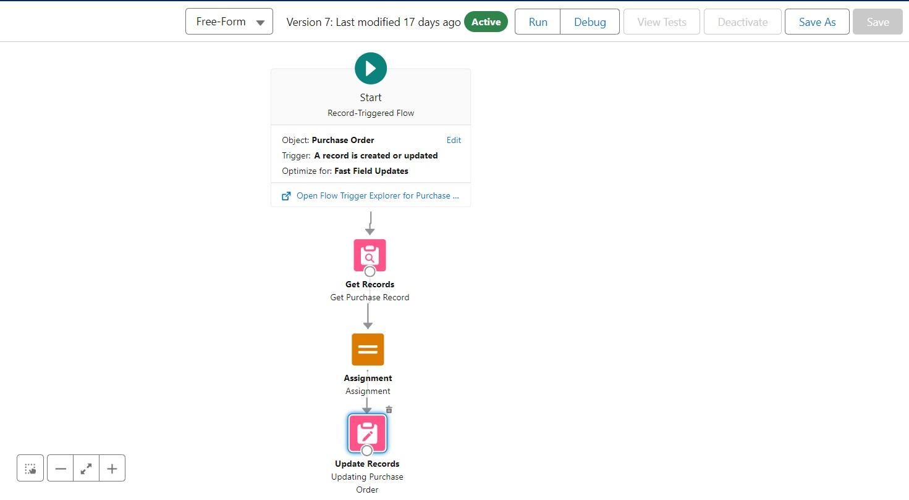

### 

### **Milestone 14 - Triggers**

Triggers in Salesforce are pieces of Apex code that execute before or after specific data manipulation events on Salesforce records, such as insertions, updates, deletions, and undeletions. They are powerful tools for automating complex business logic and ensuring data integrity by enforcing custom validation rules and workflows that cannot be achieved through declarative tools alone.

### **Activity 1 : Create a Trigger to Calculate total amount on Order Item.**

Step 1 : Login to Salesforce:

Log in to your Salesforce account with administrative privileges.

Step 2:

i)Navigate to Setup: Once logged in, click on the gear icon ?? (Setup) located at the top-right corner of the page. This will open the Setup menu.

ii)Click on Developer Console: Click on the "Developer Console" option from the Setup menu. This will open the Developer Console in a new browser tab or window.

Step 3:

i) In the Developer Console window, go to the top menu and click on "File".

ii)Select New: From the dropdown menu under "File", select "New".

iii)Choose Apex Trigger: This will open a new Apex Trigger editor tab.

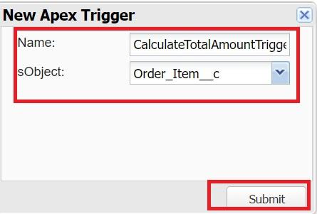

Create an Apex Trigger:

trigger CalculateTotalAmountTrigger on Order_Item__c (after insert, after update, after delete, after undelete) {

// Call the handler class to handle the logic

CalculateTotalAmountHandler.calculateTotal(Trigger.new, Trigger.old, Trigger.isInsert, Trigger.isUpdate, Trigger.isDelete, Trigger.isUndelete);

}

Step 4:

i) In the Developer Console window, go to the top menu and click on "File".

ii)Select New: From the dropdown menu under "File", select "New".

iii)Choose Apex Class: Name it as CalculateTotalAmountHandler

public class CalculateTotalAmountHandler {

// Method to calculate the total amount for Purchase Orders based on related Order Items

public static void calculateTotal(List<Order_Item__c> newItems, List<Order_Item__c> oldItems, Boolean isInsert, Boolean isUpdate, Boolean isDelete, Boolean isUndelete) {

// Collect Purchase Order IDs affected by changes in Order_Item__c records

Set<Id> parentIds = new Set<Id>();

// For insert, update, and undelete scenarios

if (isInsert || isUpdate || isUndelete) {

for (Order_Item__c ordItem : newItems) {

parentIds.add(ordItem.Purchase_Order_Id__c);

}

}

// For update and delete scenarios

if (isUpdate || isDelete) {

for (Order_Item__c ordItem : oldItems) {

parentIds.add(ordItem.Purchase_Order_Id__c);

}

}

// Calculate the total amounts for affected Purchase Orders

Map<Id, Decimal> purchaseToUpdateMap = new Map<Id, Decimal>();

if (!parentIds.isEmpty()) {

// Perform an aggregate query to sum the Amount__c for each Purchase Order

List<AggregateResult> aggrList = [

SELECT Purchase_Order_Id__c, SUM(Amount__c) totalAmount

FROM Order_Item__c

WHERE Purchase_Order_Id__c IN :parentIds

GROUP BY Purchase_Order_Id__c

];

// Map the result to Purchase Order IDs

for (AggregateResult aggr : aggrList) {

Id purchaseOrderId = (Id)aggr.get('Purchase_Order_Id__c');

Decimal totalAmount = (Decimal)aggr.get('totalAmount');

purchaseToUpdateMap.put(purchaseOrderId, totalAmount);

}

// Prepare Purchase Order records for update

List<Purchase_Order__c> purchaseToUpdate = new List<Purchase_Order__c>();

for (Id purchaseOrderId : purchaseToUpdateMap.keySet()) {

Purchase_Order__c purchaseOrder = new Purchase_Order__c(Id = purchaseOrderId, Total_Order_cost__c = purchaseToUpdateMap.get(purchaseOrderId));

purchaseToUpdate.add(purchaseOrder);

}

// Update Purchase Orders if there are any changes

if (!purchaseToUpdate.isEmpty()) {

update purchaseToUpdate;

}

}

}

}

Save it.

### 

### 

### 

### 

### 

### **Milestone 15 - Reports**

Reports in Salesforce provide a powerful way to visualize and analyze data stored in your Salesforce organization. They allow users to create, customize, and share different types of reports based on data from standard and custom objects. Reports help organizations make informed decisions by providing insights into key metrics, trends, and performance indicators.

### **Activity 1: Create a Purchase Orders based on Suppliers(Summary) Report**

1. Click App Launcher

2. Select Medical Inventory Management App

3. Click on Reports tab

4. Click on New Report.

5. Click the report type as Purchase Orders Click Start report.

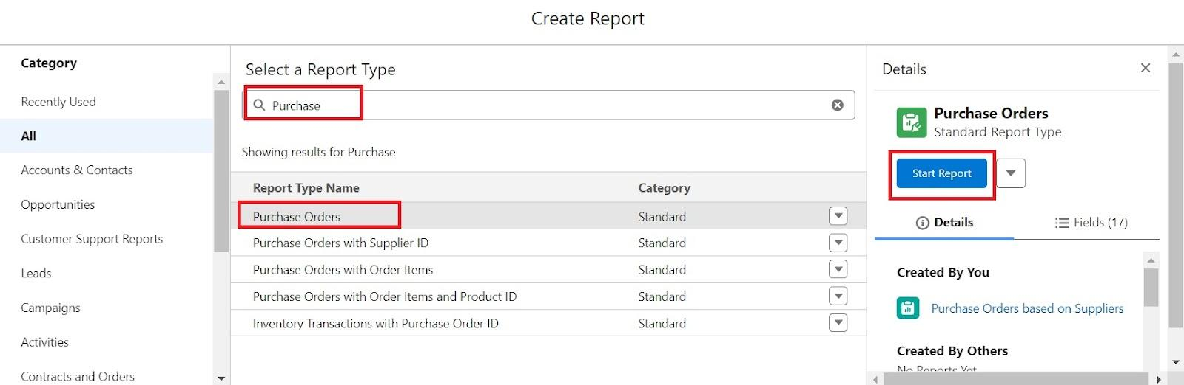

6. Click on Filters and select as follows and click on Apply

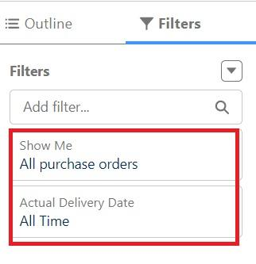

7. Customize your report, in group rows select – Supplier ID, Purchase Order: Purchase Order ID, for columns Order Count, Total Order Cost (In this way we are making a Summary Report).

8. Click save and run

9. Give report name – Purchase Orders based on Suppliers.

10. Click Save

NOTE: In this report you can see your all record of the object you selected for reporting

(What you selects in “Select a report type option”)

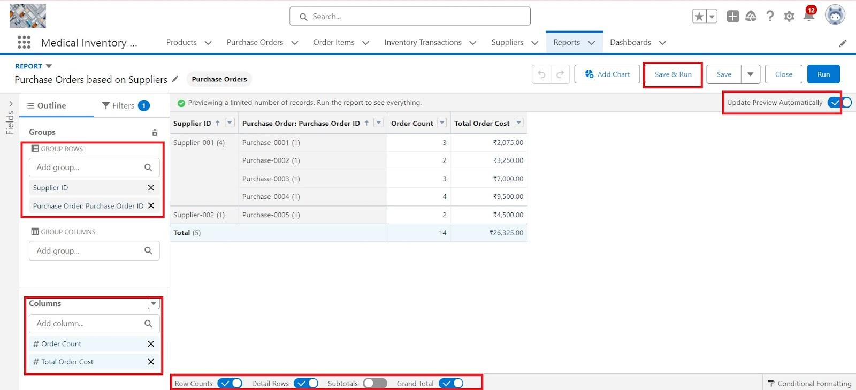

View Report

1. Click on App Launcher on the left side of the screen.

2. Search Medical Inventory Management App & click on it.

3. Click on Reports Tab.

4. Click on Purchase Orders based on Suppliers and see records.

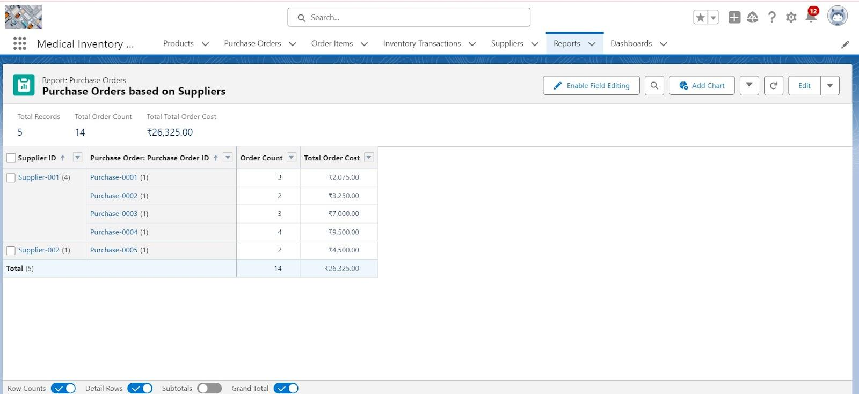

### **Activity 2: Create a Complete Purchase Details Report**

1. Click App Launcher

2. Select Medical Inventory Management App

3. Click on Reports tab

4. Click on New Report.

5. Click the report type as Purchase Orders with Order Items and Product ID >> Click Start report.

6. Click on Filters and select as follows and click on Apply



7. Customize your report, in group rows select – Supplier ID, Actual Delivery Date, Purchase Order: Purchase Order ID, for columns Product ID : Product ID, Product ID : Product Name, Order Count, Quantity Received, Amount (In this way we are making a Summary Report).

8. Click save and run

9. Give report name – Complete Purchase Details Report

10. Click Save

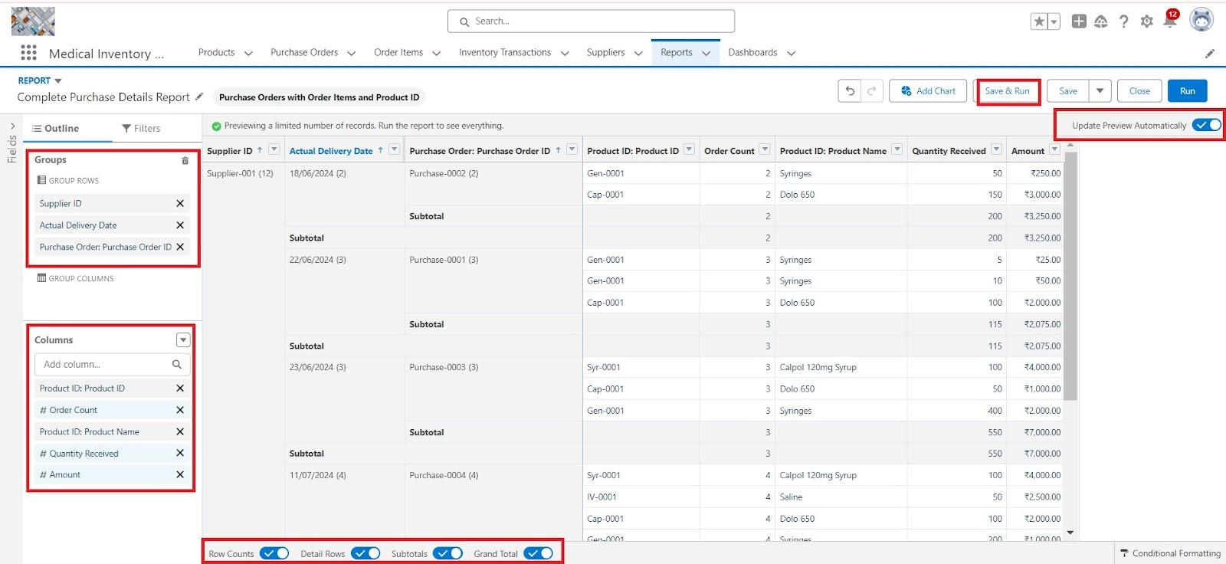

### 

### **Milestone 16 - Dashboards**

Dashboards in Salesforce are dynamic visual representations of key metrics and data from reports, providing a consolidated view of organizational performance and trends. They are powerful tools for monitoring real-time data, tracking progress towards goals, and gaining actionable insights at a glance. Dashboards consist of components such as charts, tables, metrics, and gauges that display data from underlying reports.

### **Activity 1: - Create Dashboard**

1. Click on the Dashboards tab from the Medical Inventory Management application.
2. Click on the new dashboard.
3. Give name - Medical Inventory DashBoard
4. Click create
5. Click on +widget
6. Select the Purchase Orders based on Suppliers Report
7. For the data visualization select any of the charts, tables etc. as per your choice/requirement
8. Click add.
9. Click save.

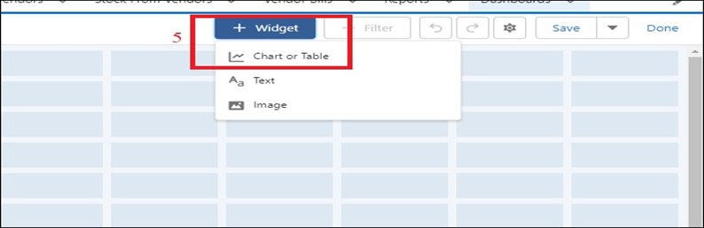

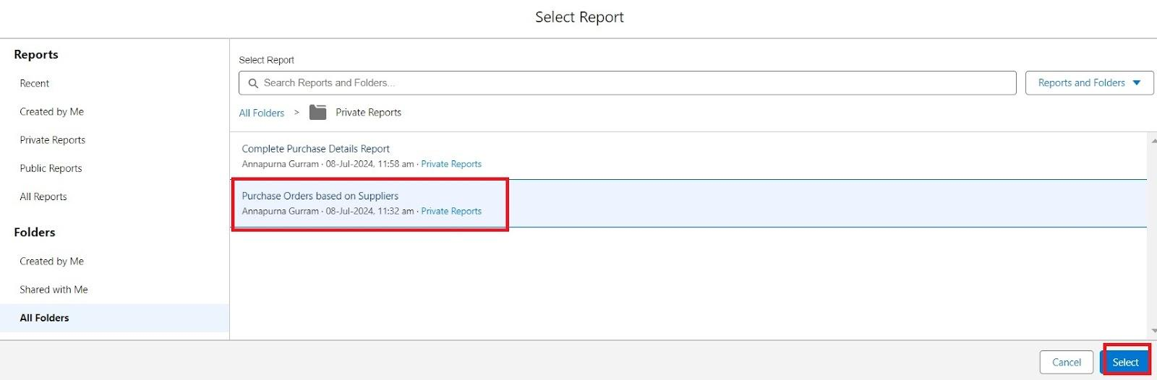

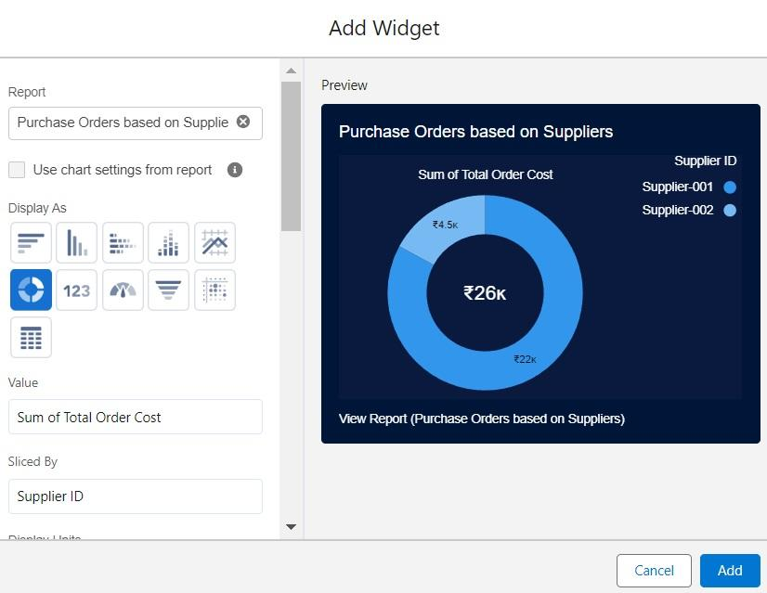

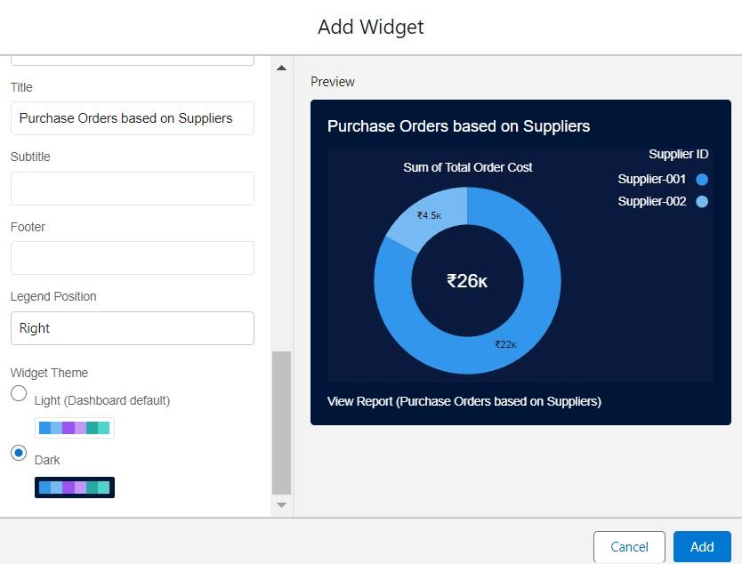

### **Activity 2: View Dashboard**

1. Click on App Launcher on the left side of the screen.

2. Search Medical Inventory Management & click on it.

3. Click on Dashboard Tab.

4. Click on Medical Inventory DashBoard see graph view of records

